GoInvestMe – A Crowdfunding Investment Platform for Startups

Final Year Project – Mid Report

Session 2015-2019A 4th Year Student

A project submitted in partial fulfilment of the

COMSATS University Islamabad, Lahore Campus

of

BSc. (Hons.)BS in Software Engineering



Department of Computer Science

COMSATS University Islamabad, Lahore Campus

17 December 2018

**Evaluation**

|  |  |  |  |  |
| --- | --- | --- | --- | --- |
| **Project Group Members** (To be filled by students) | | | | (To be filled by supervisor) |
| Sr.# | Reg. # | Student Name | *Signature | Obtained Marks  (Total Marks: 10) |
| (I) | FA15-BSE-056 | Jahanzaib Maqsood |  |  |
| (ii) | FA15-BSE-054 | Imran Latif |  |  |
| (iii) | FA15-BSE-101 | Muhammad Usama Ashraf |  |  |

*The candidates confirm that the work submitted is their own and appropriate credit has been given where reference has been made to work of others.

Supervisor Name: Sajid Ibrahim Hashmi Supervisor Signature: ______________

Remarks (if any): ______________________________________________________________

______________________________________________________________

______________________________________________________

**Abstract**

In this project, we propose to create GoInvestMe-A Crowdfunding platform for start-ups. Crowdfunding is process to collecting small number of amounts from many people to start business. This system will be used to reduce the gap between the entrepreneurs and the Investors and allow them to communicate with each other. Entrepreneurship is a way to start the business in which entrepreneur lease money from the investor and investor invest his money in the proposed project. This system shall allow the entrepreneur to create campaigns and describe how much money is needed for his campaign for some time duration that will be visible to users. After time expiring, entrepreneur will not be able to collect more money. The system shall also provide the entrepreneur to edit the campaign description. The system shall also allow the investor to create campaign but as an entrepreneur with it ID. Investor can also invest in different campaigns and companies can invest in other campaigns. The system shall allow users to search different campaigns from our database based on categories and titles The system shall allow users to search different campaigns from our database on the basis of categories and titles i.e. If investor want to invest in IT project, he can search for IT project. The system shall allow the users with a chat box functionality to share ideas and experience with other users. The system shall accurately maintain a list of campaigns for user to view. Users can view all trending campaigns, successful stories and top 10 campaigns. Users can view other user profile and can give feedback using the proposed android application or web portal. The Website will be MVC based and shall be using ASP NET technologies for development and using SQL SERVER as a Database service. While the Android shall be created in Xamarin and shall be using the Web APIs to communicate with the Server. Database control and other admin responsibilities will be provided at admin panel.

Table of Contents

Chapter 1 : Introduction 1

1.1 : Introduction 1

1.1.1 : Entrepreneurship 1

1.1.2 : Crowdfunding 1

1.1.2.1 : Types of Crowdfunding 1

1.1.2.2 : Working of Crowdfunding Platform 1

1.1.2.3 : What is in it for Investors? 2

1.1.3 : Entrepreneurs 2

1.1.3.1 : Types of Entrepreneurship 2

1.1.4 : Investor 2

1.1.4.1 : Types of Investors 2

1.2 : Objectives 2

1.3 : Problem Statement 3

1.4 : Assumptions 3

1.5 : Constraints 3

1.6 : Project Scope 3

Chapter 2 : Requirement Analysis 4

2.1 : Literature Review 4

2.1.1 : EquityNet 4

2.1.2 : KickStarter 4

2.1.3 : Patreon 5

2.1.4 : Pledge Music 6

2.2 : Stakeholders List (Actors) 6

2.3 : Requirements Elicitation 6

2.3.1 : Functional Requirements 6

FR01: Entrepreneur / Investor Account Registration 6

FR02: Company Account Registration 7

FR03: Sign In 7

FR04: Add New Campaign 7

FR05: Delete a Campaign 8

FR06: Update Campaign 8

FR07: Modify Profile 8

FR08: View Investment 8

FR09: Receive Payment 9

FR10: Make Investment 9

FR11: Returns of Investment 9

FR12: Search campaigns 9

FR13: Reports 9

FR14: Campaigns description: 10

FR15: Provide any help 10

FR16: Complains/Feedback 10

FR17: Display Campaigns: 10

FR18: Conversation 11

FR19: Comments 11

FR20: Notification 11

2.3.2 : Non-Functional Requirements 11

NFR01: Performance 11

NFR02: Security 12

NFR03: Maintenance 12

NFR04: Documentation 12

NFR05: Disaster Recovery 12

NFR06: Usability 12

NFR07: Integrity 12

NFR08: Flexibility 13

NFR09: Portability 13

2.3.3 : Requirement Traceability Matrix 13

2.4 : Use Case Diagram and Descriptions 16

2.4.1 : Registration 17

UC01: Sign Up 17

2.4.2 : Campaign 18

UC02: Add Campaign 19

UC03: Edit Campaign 19

UC04: Delete Campaign 20

UC05: View Campaign 21

UC06: Search Campaign 21

2.4.3 : Profile 22

UC07: View Profile 23

UC08: Edit Profile 23

2.4.4 : Investment 24

UC09: Make Investment 24

UC10: View Investment 25

UC11: Receive Investment 26

2.4.5 : Payroll 27

UC12: Manage Payroll 27

UC13: Run Payroll 28

2.4.6 : Conservation 29

UC14: Manage Comments 29

UC15: Chat 30

2.4.7 : Notification 31

UC16: Get Notification 31

2.4.8 : Login 32

UC17: Login 32

2.5 : Software Development Life Cycle Model 33

2.5.1 : Why use Waterfall Model? 33

2.5.2 : Why use Rapid Prototyping Model? 34

Chapter 3 : System Design 35

3.1 : Work Breakdown Structure (WBS) 35

3.2 : Activity Diagram 37

3.2.1 : Sign Up 37

3.2.2 : Add Campaign 38

3.2.3 : Edit Campaign 39

3.2.4 : Delete Campaign 39

3.2.5 : Search 40

3.2.6 : View Profile 40

3.2.7 : Edit Profile 41

3.2.8 : Make Investment 42

3.2.9 : View Investment 42

3.2.10 : Receive Investment 43

3.2.11 : Manage Payroll 44

3.2.12 : Manage Comments 45

3.2.13 : Chatting 45

3.2.14 : Notification 46

3.2.15 : Login 46

3.2.16 : Run Payroll 47

3.3 : Sequence Diagram 47

3.3.1 : Chatting 48

3.3.2 : Feedback 48

3.3.3 : Comments 49

3.3.4 : Make Investment 49

3.3.5 : Receive Investment 50

3.3.6 : Sign Up and Login 50

3.3.7 : Profile 51

3.3.8 : Campaign 51

3.3.9 : Search and View Campaign 52

3.4 : Software Architecture 52

3.4.1 : MVC Architecture 52

3.5 : Class Diagram 53

3.6 : Database Diagram 54

3.7 : Network Diagram (Gantt chart) 54

3.8 : Collaboration Diagram 55

3.8.1 : Chatting 55

3.8.2 : Feedback 56

3.8.3 : Make Investment 56

3.8.4 : Receive Investment 56

3.8.5 : Sign Up and Login 57

3.8.6 : Profile 57

3.8.7 : Campaign 58

3.8.8 : Search and View Campaign 58

Chapter 4 : System Testing 59

4.1 : Test Cases 59

TC-01: Sign Up 59

TC-02: Add Campaign 60

TC-03: Edit Campaign 60

TC-04: Delete Campaign 61

TC-05: View Campaign 62

TC-06: Delete Campaign 62

TC-07: View Profile 63

TC-08: Edit Profile 64

TC-09: Make Investment 64

TC-10: View Investment 65

TC-11: Receive Investment 66

TC-12: Login 66

TC-13: Payroll System 67

TC-14: Run Payroll 68

TC-15: Comments 69

TC-16: Chat 70

TC-17: Change Password 70

TC-18: Notification Services 71

4.2 : Unit Testing 72

4.3 : Integration Testing 72

4.4 : System Testing 72

Chapter 5 : Prototype 74

5.1 : Header 74

5.2 : Footer 74

5.3 : Trending Projects 74

5.4 : Search 75

5.5 : Show Campaign 75

5.6 : Sign Up 76

5.7 : Login 77

5.8 : Detail for Investment 78

Chapter 6 : Code 79

6.1 : _header.cshtml 79

6.2 : _footer.cshtml 82

6.3 : _layout.cshtml 83

6.4 : Index 84

6.5 : Site.css 90

Chapter 7 : Conclusion 93

7.1 : Problems 93

7.2 : Lessons Learnt 93

7.3 : Project Summary 93

7.4 : Future Work 93

7.4.1 : Translation 94

7.4.2 : Artificial Intelligence 94

7.4.3 : SSL Certification 94

7.4.4 : Copyrights 94

**List of Figures**

Figure 1 : Crowdfunding Platform Working 1

Figure 2: TrustScore KickStarter Reputation 1 5

Figure 3: TrustScore KickStarter Reputation 2 5

Figure 4: UC – Registration 17

Figure 5: UC – Campaign 18

Figure 6: UC – Profile 22

Figure 7: UC – Login 24

Figure 8: UC – Investment 24

Figure 9: UC – Payroll 27

Figure 10: UC – Conversation 29

Figure 11: UC – Notification 31

Figure 12: UC – Login 32

Figure 13: Proposed SDLC Hybrid Model 34

Figure 14: Work Breakdown Structure 36

Figure 15: AD – Sign Up 37

Figure 16: AD – Add Campaign 38

Figure 17: AD – Edit Campaign 39

Figure 18: AD – Delete Campaign 39

Figure 19: AD – Search 40

Figure 20: AD – View Profile 40

Figure 21: AD – Edit Profile 41

Figure 22: AD – Make Investment 42

Figure 23: AD – View Investment 42

Figure 24: AD – Receive Investment 43

Figure 25: AD – Manage Payroll 44

Figure 26: AD – Manage Comments 45

Figure 27: AD – Chatting 45

Figure 28: AD – Notification 46

Figure 29: AD – Login 46

Figure 30: AD – Run Payroll 47

Figure 31: SD – Chatting 48

Figure 32: SD – Feedback 48

Figure 33: SD – Comments 49

Figure 34: SD – Make Investment 49

Figure 35: SD – Receive Investment 50

Figure 36: SD – Sign Up and Login 50

Figure 37: SD – Profile 51

Figure 38: SD – Campaign 51

Figure 39: SD – Search and View 52

Figure 40: MVC Architecture 52

Figure 41: Class Diagram 53

Figure 42: ERD – Database Diagram 54

Figure 43: Gantt Chart 55

Figure 44: CD – Chatting 55

Figure 45: CD – Feedback 56

Figure 46: CD – Make Investment 56

Figure 47: CD – Receive Investment 56

Figure 48: CD – Sign Up & Login 57

Figure 49: CD – Profile 57

Figure 50: CD – Campaign 58

Figure 51: CD – Search and View Campaign 58

Figure 52: Header 74

Figure 53: Footer 74

Figure 54: Trending Projects 74

Figure 55: Search 75

Figure 56: Show Campaign 75

Figure 57: Sign Up 76

Figure 58: Login 77

Figure 59: Detail for Investment 78

# Introduction

## Introduction

### Entrepreneurship

From the starting of human history, people use to do business in the various way. In the 20st Century Entrepreneurship taking place. Entrepreneurship is the technique or process that is used to start a new business or expanding the business. The individual who create the ideas for his business is known as Entrepreneur.

Richard Cantillon (Irish French Economist) first study the entrepreneurship in late 17th and early 18th century. In medieval time’s guilds in Germany, a special permission is needed for an artisan to work as an entrepreneur.

### Crowdfunding

Crowdfunding is process of collecting small number of amounts from many people to start business Venture or expand a working business.

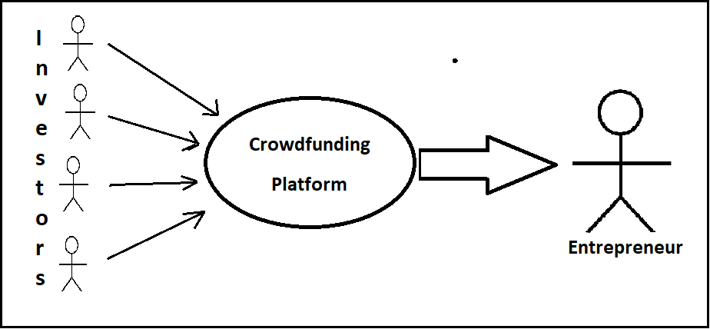

Figure 1 : Crowdfunding Platform Working

#### Types of Crowdfunding

* Reward
* Equity
* Donation
* Litigation
* Debt

#### Working of Crowdfunding Platform

Entrepreneurs can raise funds from anyone with money to invest from the Crowdfunding platform. Crowdfunding provides a platform to share the ideas with the investors. Shiroi Hana a restaurant in USA need $ 32,000 and raised fund of $ 429,860, which is 1,330 % of required amount via Kickstarter a reward, based crowdfunding platform. These platforms generate income from a percentage of total funds raised.

#### What is in it for Investors?

Mostly crowdfunding platform are reward based like Kickstarter, Patreon. They invite investors to fund the projects in exchange of gifts for their investments. Such as, the maker of a new game sends the early copies of their games to its investors.

The popularity of equity based is growing in because it allows entrepreneurs to raise funds from investors without giving up control on their venture.

### Entrepreneurs

Entrepreneur is a person that start a new venture while taking risk, study the market opportunities and plan, organize, deploy the resources for the creating a new innovation or to improve present services or products.

#### Types of Entrepreneurship

* Small Business
* Scalable Start-up
* Large Company

### Investor

Investor may be a person or an organization that invest finance in any other business with expectation of maximum profit return. They avoid from risk, if the chance of any risk then they do not invest finance in other ideas.

#### Types of Investors

* Ting
* Angel Investor
* Peer to Peer Lender
* Venture Capitalist
* Personal Investor

## Objectives

In this project, we aim to develop relationship between entrepreneurs and investors keeping following objectives in mind:

* GoInvestMe will facilitate both entrepreneurs and investors.
* Our object is to develop GoInvestMe, which will help business community to increase the efficiency of their business by entrepreneurs and investors to operate online rather than moving product to traditional manual systems.
* Database access minimize risks against traditional time taking procedures.
* Increasing business opportunities by reducing time cost.
* Efficient interconnectivity between entrepreneurs, funders and investors.
* Technology shift towards smart devices.
* Generate reports, which will be helpful in business intelligence and future business plans.
* A proper look at the business or start ups
* To make easy for the entrepreneurs to start the business and launching their ideas
* To make easy for the funders and investors to make investments and funding
* To make fundraising quickly for the business proposer
* To make available the system at user’s place
* No need to make organization like traditional

## Problem Statement

The project we are working on “GoInvestMe – A Crowdfunding Platform” solves the problems faced by Investor and Entrepreneurs. Many people with a good prototype cannot find people to invest on the prototype to start it industrial process and some people want to invest in business but cannot find a right Platform that they can invest in. “GoInvestMe – A Crowdfunding Platform” will give investor and entrepreneurs, a right platform so they can do investment and help grow business. This solves the problem faced by investor and entrepreneurs in getting and the investment.

We investigated numerous Crowdfunding Platform to see which inadequacies they need to improve a Crowdfunding Platform, which tackles the issues and restrictions confronted. One of the major issues we saw was that mostly Crowdfunding platform are Reward based and donation based but not specific for equity based so they use APIs for equity based. Therefore, users have to go to other websites or platform where they have to create new account for that platform.

## Assumptions

* The project will enable investors to invest in the projects.
* The project will enable entrepreneurs to get funds for their projects.
* The entrepreneurs decide how many investors he is working with as it is joint venture
* The project will be able to manage projects, generate reports and manage access levels.
* Admin do not have access to any sensitive information regarding to investor and entrepreneurs such that their Credit Card no.

## Constraints

* The android phone was required with minimum of 4.2(Lollipop) version of android OS in it so application can test on it
* The project will be completed within given timeframe and allocated budget.
* The project will be developed in .NET framework, with Microsoft SQL server as database server.

## Project Scope

The project will include the SRS document design, implementation, testing and deployment of an improved GoInvestMe – A Crowdfunding Investment Platform for Start-ups. Its main functions are creating environment between entrepreneurs and investors or lenders, opportunities for entrepreneurs to start business, to get donations from the volunteer investors and providing platform for entrepreneur to raise their funding. The project is developed through the software development perspectives. The project is divided into two different frameworks (website and mobile application). The website and application will be online available to the entrepreneurs and the investors. Whole project work will independent of daily ongoing and operations and the testing will be performed according to testing criteria and rules. All the history will be preserved in the databases. The project will be completed when the system will be tested and final report will be submitted

There is no need to configure a new server, operations will configure server already bought. New tools do not be implemented again; previously implemented tools will be reused. No recruitment required for resources of system once the new system will be launched and procurement of maintenance contracts will not be included in project.

# Requirement Analysis

The process to fulfil user needs for a new or existed product is called requirement analysis. These needs can be implemented by requirements that must be measureable, applicable and detailed. Functional means giving service to the user.

Requirement Analysis is important because all the needs can be fulfilled. The main task is to ensure all the requirements that all stakeholders understand them

## Literature Review

As far back as the World Wide Web, there have been actions to utilize the web to request assets for individuals, activities, and establishments that generally would battle for financing.

### EquityNet

* <https://www.equitynet.com>

EquityNet is an equity crowdfunding platform interfacing organizations to investors. The Company was established in Fayetteville, Arkansas in 2005.

Before JOBS Act in 2013 EquityNet could just share organizations' pitches to investors privately. Upon the JOBS Act producing results, EquityNet started enabling organizations on the platform to openly request funding.

Alongside its crowdfunding platform, EquityNet additionally offers cloud Software that enables you to fabricate a strategy that will be distinguishable to investors and help them choose if your business merits a venture. Actually, you do not need to utilize EquityNet for raising money by any stretch of the imagination — on the off chance that you wish, you can simply utilize the product to examine and streamline your business planning.

### KickStarter

* <https://www.kickstarter.com>

Kickstarter founded in 2009 is the most common crowdfunding platform.

Kickstarter is committed to the crowdfunding of imaginative tasks. Not at all like such administrations as your undertaking must meet its raising money objectives inside a set timeframe before you get any subsidizing. Besides, when your task works out as intended, you are committed to give rewards to your backers. These prizes must be of your creation.

As indicated by their site, Kickstarter has over 4.05 billion dollars vowed to its activities, more than 155 Thousand effectively supported undertakings, and more than 15.6 million aggregate sponsor.

The Five rules of Kick Starter for every Project

* Projects must clearly have presented.
* Projects cannot be of charity
* Projects cannot offer equity
* Projects cannot involve banned items such as drugs.
* Projects must create something

Condition to Start Kickstarter Project:

* You are 18 or older
* You are creating a project in your own name
* You have an address
* You have an government-issued ID Card
* You have an bank account
* The linked bank account must belong to you
* You have a credit or debit card

Complaints proliferate from the two creators and backers over an assortment of issues. Kickstarter right now has a 0.7 out of 10 rating on Trustpilot, where you'll locate various complaints in regards to poor client benefit, inconsistent crusades that neglect to convey on their guarantees notwithstanding when completely subsidized, and lousy help for creators — even those with a reputation of effective ventures.

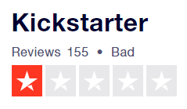

Figure 2: TrustScore KickStarter Reputation 1

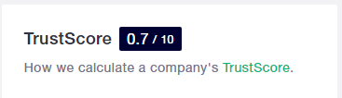

Figure 3: TrustScore KickStarter Reputation 2

### Patreon

* <https://www.patreon.com>

Patreon is a crowdfunding website gone for a specific group of people: Artist and other. As crowdfunding stages go, Patreon has delighted in a fleeting ascent in its public profile in the course of recent years.

Patreon way to deal with remunerations based crowdfunding is special, separating it from any semblance of Kickstarter. Though with the last two, backers support with one-time vows in return for rewards, Patreon model is that benefactors — patrons, as Patreon mentions them — buy in to the substance of the maker, making-repeating installments on a continuous premise in return for access to the creator’s content. Patreon proclaims itself a crowdfunding stage for creator, as its stage enables makers to draw a consistent, ceaseless salary from The Crowd. This subsidizing model makes Patreon especially appropriate to creators of viral recordings, online columnists, journalists, and performers.

Their terms of use forbid users from

* Racism
* Fraud
* Abuse
* Spam
* Intellectual Property Infringement

### Pledge Music

* <https://www.pledgemusic.com>

Pledge Music says their organization gives the most creative ways for their individuals to be required with the musicians take while releasing their new work.

Fans can sign up for Pledge Music membership free and start searching for their favorite artists to perceive what things you might be keen on "pledging" for.

Pledge Music won't offer refunds except if a circumstance has happened where a pledge has gone unfulfilled, at which time they will assess the individual conditions and refunds the fan’s cash.

## Stakeholders List (Actors)

|  |  |
| --- | --- |
| **Stakeholder** | **Description** |
| Administrator | Administrator is responsible for managing admin panel. |
| Entrepreneurs | Entrepreneurs can post their ideas and receive funds. |
| Investors | Investor invests payment on entrepreneur’s ideas and get revenue. |
| Company | Company can invest payments, post ideas, and receive payments. |

## Requirements Elicitation

Requirements elicitation is the process of studying and finding requirements of a software from users and other stakeholders. This process can also be called as requirement gathering.

It is important because requirements will be collected through a requirements elicitation process before requirements can be analyzed.

### Functional Requirements

Requirement is condition or capability that is to be implemented to full fill user need.

A functional requirement can be functionality of a system or tasks of the system. It also depends upon the type of users, software and system in which environment the software is being used.

Functional user requirements are what the system actually perform, upper-level statements of what the software can do. Functional requirements would be clear and in specific detail.

#### FR01: Entrepreneur / Investor Account Registration

|  |  |
| --- | --- |
| **Req. No.** | **Functional Requirements** |
| FR01-01 | The System shall enable the Entrepreneur / Investor to Create/Register the Account. |
| FR01-02 | The system shall not allow creating more than one account on same username/email. If already account exist, system shall notify and provide option to Log In directly. |
| FR01-03 | The system shall validate the account by confirmation message. |
| FR01-04 | The system shall allow the Entrepreneur / Investor to register through social media account. |

#### FR02: Company Account Registration

|  |  |
| --- | --- |
| **Req. No.** | **Functional Requirements** |
| FR02-01 | The System shall enable the company to Create/Register the Account. |
| FR02-02 | The system shall not allow creating more than one account on same username/email. If already account exist, system shall notify and provide option to Log In directly. |
| FR02-03 | The system shall the admin to validate the account by checking company’s business details. |
| FR02-04 | The system shall not allow the company to register through social media account. |

#### FR03: Sign In

|  |  |
| --- | --- |
| **Req. No.** | **Functional Requirements** |
| FR03-01 | The System shall enable the Entrepreneur/Investor /company to Log In the system. |
| FR03-02 | The system shall allow resetting the password if password is forgotten by using email/phone or security questions. |

#### FR04: Add New Campaign

|  |  |
| --- | --- |
| **Req. No.** | **Functional Requirements** |
| FR04-01 | The System shall enable the Entrepreneur to add new campaign or new idea for the investment. |
| FR04-02 | The System shall enable the Entrepreneur to add pictures, videos of that campaign. |
| FR04-03 | The System shall enable the Entrepreneur to choose the estimate the fund needed. |
| FR04-04 | The System shall enable the Entrepreneur to select maximum number of investors for that campaign. |
| FR04-05 | The System shall enable the Entrepreneur to select the category of that campaign. |
| FR04-06 | The System shall enable the Entrepreneur to choose the tags (max 5) for that campaign. |
| FR04-07 | The System shall enable the Entrepreneur create a team with other Entrepreneurs |

#### FR05: Delete a Campaign

|  |  |
| --- | --- |
| **Req. No.** | **Functional Requirements** |
| FR05-01 | The system shall enable the Entrepreneur to delete recent campaign that has no investment. |
| FR05-02 | The system shall maintain the deleted record of campaign. |

#### FR06: Update Campaign

|  |  |
| --- | --- |
| **Req. No.** | **Functional Requirements** |
| FR06-01 | The system shall enable the Entrepreneur to edit the description, pictures, videos or fund needed of campaign. |
| FR06-02 | The system shall not able to edit the campaign title. |
| FR06-03 | The system shall unable to edit the team of entrepreneurs. |

#### FR07: Modify Profile

|  |  |
| --- | --- |
| **Req. No.** | **Functional Requirements** |
| FR07-01 | The system shall enable the Entrepreneur and investors to modify their email, password, profile pictures, address. |
| FR07-02 | The system shall unable the user to edit its username. |

#### FR08: View Investment

|  |  |
| --- | --- |
| **Req. No.** | **Functional Requirements** |
| FR08-01 | The system shall enable the investors to view their investment that he has invested in different campaign. |
| FR08-02 | The system shall enable the entrepreneurs to view funds that he has received from different campaigns. |
| FR08-03 | The system shall enable the entrepreneurs to view its investment report that contains graphs of receiving funds and remaining funds. |

#### FR09: Receive Payment

|  |  |
| --- | --- |
| **Req. No.** | **Functional Requirements** |
| FR09-01 | The system shall enable the entrepreneurs to receive funds through payroll systems. |
| FR09-02 | The system shall enable the entrepreneurs to check report how much payment is received. |

#### FR10: Make Investment

|  |  |
| --- | --- |
| **Req. No.** | **Functional Requirements** |
| FR10-01 | The system shall enable the investor to invest in different campaigns in which entrepreneur want funds. |
| FR10-02 | The system shall enable the investor to invest in different companies where companies want to share. |
| FR10-03 | The system shall enable the companies to invest in different companies where companies want to share their business. |

#### FR11: Returns of Investment

|  |  |
| --- | --- |
| **Req. No.** | **Functional Requirements** |
| FR11-01 | The system shall enable the entrepreneurs to send back profit through payroll systems to investors or companies. |
| FR11-02 | The system shall enable the companies to send back profit through payroll systems to investors or companies. |
| FR11-03 | The system shall not able the investors to take money back before fixed duration. |

#### FR12: Search campaigns

|  |  |
| --- | --- |
| **Req. No.** | **Functional Requirements** |
| FR12-01 | The system shall enable the entrepreneurs, companies and Investor to search campaigns using tags, categories, campaign titles or campaign region. |
| FR12-02 | The system shall able the admin to search campaigns at admin panel with complete description that entrepreneurs provides. |

#### **FR13: Reports**

|  |  |
| --- | --- |
| Req. No. | Functional Requirements |
| FR13-01 | The system shall enable the admin to generate the reports of campaigns and investments on daily basis, monthly and yearly. Admin also able to generate reports on status and specific date time wise. |
| FR13-02 | The System shall allow the Entrepreneur to generate the reports that the Entrepreneur take get payment. |
| FR13-03 | The system shall allow the investor to generate the reports that they invested in different campaigns. |

#### **FR14: Campaigns description:**

|  |  |
| --- | --- |
| Req. No. | Functional Requirements |
| FR14-01 | The system shall display the campaigns ‘details to entrepreneurs , investors and companies |
| FR14-02 | The system shall not able to edit that description to anyone other than the one who started campaigns |

#### **FR15: Provide any help**

|  |  |
| --- | --- |
| Req. No. | Functional Requirements |
| FR15-01 | The system shall provide the online help FAQ’s, Sitemap to entrepreneurs or investors For any Query related to System Working process |
| FR15-02 | The system shall display the support email on the screen. |

#### FR16: Complains/Feedback

|  |  |
| --- | --- |
| **Req. No.** | **Functional Requirements** |
| FR16-01 | The system shall enable the entrepreneurs or investors to give feedback about the system, any investor, and entrepreneur company. |
| FR16-02 | The system shall enable the entrepreneurs or investors to give complains about the system, any investor, entrepreneur company. |
| FR16-03 | The system shall enable the admin to proceed on complains and feedback |

#### **FR17: Display Campaigns**:

|  |  |
| --- | --- |
| **Req. No.** | **Functional Requirements** |
| FR17-01 | The system shall display the campaigns with title name, picture and little description where investor can click to make investment. |
| FR17-02 | The system shall display the campaigns regarding new ,top 10 and trending campaigns using different algorithms to Entrepreneurs and investors |

#### FR18: Conversation

|  |  |
| --- | --- |
| **Req. No.** | **Functional Requirements** |
| FR18-01 | The system shall enable the entrepreneurs and investors to contact each other if any information needed about campaigns or other issues |
| FR18-02 | The system shall enable the entrepreneurs and investors to launch group conservation if campaigns has more than one entrepreneurs. |

#### FR19: Comments

|  |  |
| --- | --- |
| **Req. No.** | **Functional Requirements** |
| FR19-01 | The system shall enable the different entrepreneurs and investors to negotiate each other if any information needed about campaigns. |
| FR19-02 | The system shall enable the entrepreneurs and investors to edit or update the comments |
| FR19-03 | The system shall enable the entrepreneurs and investors to like or dislike campaigns |

#### FR20: Notification

|  |  |
| --- | --- |
| **Req. No.** | **Functional Requirements** |
| FR20-01 | The system shall notify the entrepreneur when investor make investment for his campaign |
| FR20-02 | The system shall notify the user when any complain or feedback is given |

### Non-Functional Requirements

Non-functional requirement tells about the behaviour of the system that is being developed. It tells about the constraints on systems behaviour. It can be imagined that non-functional requirements are quality attributes of a system. It tells about the system performance, usability, security and maintainability at straw.

#### NFR01: Performance

|  |  |
| --- | --- |
| **Req. No.** | **Non Functional Requirements** |
| NFR01-01 | The starting page must be opened in average time of 4 seconds. |
| NFR01-02 | The system should take less than 8 seconds for processing any transaction. |
| NFR01-04 | The average responding time of s system must not be more than 5 seconds |
| NFR01-06 | The system must enable 1000 users to do operations at a time |

#### NFR02: Security

|  |  |
| --- | --- |
| **Req. No.** | **Non Functional Requirements** |
| NFR02-01 | User can only access the system through log in. |
| NFR02-02 | When the user expires, no data must be saved in the user computer. |

#### NFR03: Maintenance

|  |  |
| --- | --- |
| **Req. No.** | **Non Functional Requirements** |
| NFR03-01 | After releasing the system, the bugs should not exceed 5 bugs per year. |
| NFR03-02 | Fixing the bus should be in 5 hours after releasing the system. |

#### NFR04: Documentation

|  |  |  |
| --- | --- | --- |
| **Req. No.** | **Non Functional Requirements** | |
| NFR04-01 | Help documentation contain data about each module and functionality defined by system must be completed. |
| NFR04-02 | There should be help option at all web pages to help the user. |

#### NFR05: Disaster Recovery

|  |  |
| --- | --- |
| **Req. No.** | **Non Functional Requirements** |
| NFR05-01 | If the system crash ,the information should be recovered in 40 minutes after the event |

#### NFR06: Usability

|  |  |
| --- | --- |
| **Req. No.** | **Non Functional Requirements** |
| NFR-06 | The usability scale of the system must be strong enough, it should be effective so that the user can achieve goals successfully, it should be efficient so that the less efforts and resources would be utilized to achieve those goals and it must satisfy the user needs. |

#### NFR07: Integrity

|  |  |  |
| --- | --- | --- |
| **Req. No.** | | **Non Functional Requirements** |
| NFR-07 | System’s integrity should be maintained on highest priority the disruptions, changes in the external and internal environment do not affect the system, and system will perform its functions without being interrupt. |

#### NFR08: Flexibility

|  |  |
| --- | --- |
| **Req. No.** | **Non Functional Requirements** |
| NFR-08 | The system should be flexible, which can adapt several internal changes. System recovery will also be ensured. |

#### NFR09: Portability

|  |  |  |
| --- | --- | --- |
| **Req. No.** | **Non Functional Requirements** | |
| NFR-09 | System should be portable enough which can be operate on several o web browsers such as Chrome, Opera, Firefox and Microsoft Edge. |

### Requirement Traceability Matrix

Requirements Traceability Matrix (RTM) is a tool to ensure that test cases can fulfil the requirements, project scope when compared to user requirements.

It is a solution to keep requirements and tests is a Requirements Traceability Matrix (RTM)

Typically, requirements are defined in one column and test cases are defined is other column and compared to each other.

It is important because, we can track the record which requirements is tested or which is not.

|  |  |  |  |  |  |  |  |
| --- | --- | --- | --- | --- | --- | --- | --- |
| ID | FR-ID | FR-Description | Business needs | Project Objective | Priority | Use Case | Test Case |
| 1 | FR-01 | The System shall enable the Entrepreneur / Investor to Create the Account. | User will have access to enter the system | Registration of Entrepreneur / Investor | H | Register | Sign in |
| 2 | FR-02 | The System shall enable the company Create the Account. | Company will have access to enter the system | Registration of company | H | Register | Sign in |
| 3 | FR-03 | The system shall allow user to login the system | User logged into the system | Log in in the system | H | Log in | Log in |
| 4 | FR-04 | The System shall enable the Entrepreneur to add new campaign or new idea for the investment. | User add new campaign | Add Campaign in the system | H | Add Campaign | Add Campaign |
| 5 | FR-05 | The system shall enable the Entrepreneur to delete recent campaign that has no investment. | User delete recent campaign | Delete Campaign from the system | H | Delete Campaign | Delete Campaign |
| 6 | FR-06 | The system shall enable the Entrepreneur to edit the description, pictures, videos or fund needed of campaign. | User update campaign | Update Campaign from the system | H | Edit Campaign | Edit Campaign |
| 7 | FR-07 | The system shall enable the Entrepreneur and investors to modify their email, password, profile pictures, address. | User edit his profile | Update profile from the system | H |  |  |
| 8 | FR-08 | The system shall enable the investors to view their investment that he has invested in different campaign. | User can view his investments | View investments from the system | H | View investments | View investments |
| 9 | FR-09 | The system shall enable the entrepreneurs to receive funds through payroll systems. | User can receive his payments | Receive payments from investor | H | Receive payments | Receive payments |
| 10 | FR-10 | The system shall enable the investor to invest in different campaigns in which entrepreneur want funds. | Investor can invest in campaign | Invest in campaign | H | Make investment | Make investment |
| 11 | FR-11 | The system shall enable the entrepreneurs to send back profit through payroll systems to investors or companies. | Investor get back profit | Return of investment | H | Manage payroll | Payroll  System |
| 12 | FR-12 | The system shall enable the entrepreneurs, companies and Investor to search campaigns using tags ,categories ,campaign titles or campaign region | User can search for campaign | Finding any campaign | H | Search campaign | Search campaigns |
| 13 | FR-13 | The system shall allow the investor to generate the reports that they invested in different campaigns. | User can generate report | Generate report | M | View report | View report |
| 14 | FR-14 | The system shall display the campaigns ‘details to entrepreneurs , investors and companies | User can view campaign description | Campaign in detail | M | View campaign | View campaign |
| 15 | FR-15 | The system shall provide the online help FAQ’s, Sitemap to entrepreneurs or investors For any Query related to System Working process | User can rake help from admin | Providing help | M | Get notification | Not services notification |
| 16 | FR-16 | The system shall enable the entrepreneurs or investors to give feedback about the system, any investor, entrepreneur and company. | User give feedback or complain any user | Report a bug or user | M | Get notification | Notification  services |
| 17 | FR-17 | The system shall display the campaigns with title name ,picture and little description where investor can click to make investment | User can view campaigns | Displaying campaigns in order | H | View campaign | View campaign |
| 18 | FR-18 | The system shall enable the entrepreneurs and investors to contact each other if any information needed about campaigns or other issues | User can contact each other | Chat room for user | M | Chat | chatting |
| 19 | FR-19 | The system shall enable the different entrepreneurs and investors to negotiate each other if any information needed about campaigns. | User can comments at campaign | Managing comments | M | Manage comments | Comments |
| 20 | FR-20 | The system shall notify the entrepreneur when investor make investment for his campaign or comments | To notify user when any operation happens | Notification service | M | Get notification | Notification  services |

## Use Case Diagram and Descriptions

Use cases are used to identify system functionality for the analysis of a project

 A use case is a description of how different users will execute operations on your software. It tells about user’s aspect; a software responds as it reacts to an application. Every use case is signified as an order of steps, beginning with a pre-condition then flow of steps and ending when that post condition. It also highlights what can be exceptions in that module implemented in this system.

Use case diagram is a graphic description of any system. How system elements interact with each other. A use case is a method used in system for analysis, organizing and identification of system requirements. Use case diagram contain actors, external systems and use cases. How actors interact with use case and how use cases are linked with the external system.

### Registration

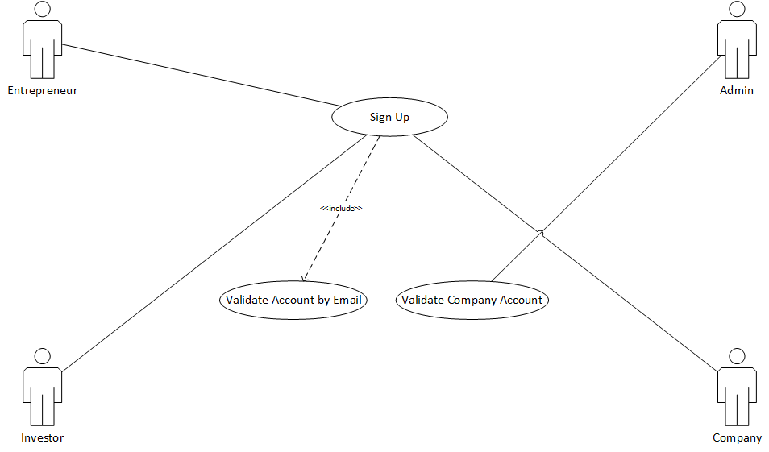

Figure 4: UC – Registration

#### UC01: Sign Up

|  |  |  |
| --- | --- | --- |
| **ID :** 001 | | **Name :** Sign Up |
| **Priority** | High | |
| **Actors** | Investors, Entrepreneurs | |
| **Summary** | Before using this platform functionality , first user will be sign up on this platform | |
| **Precondition** | User must have valid data | |
| **Normal Flow of Events** | | **Alternative Path** |
| This use case will start when web site will launch | |  |
| User enter valid email and First Name, last name, and address, gender and contact information. | |  |
| After that user set his password. And click on sign up button | | User will not follow the password regex then user will receive error notification. |
| User will be receive confirmation mail. | |  |
| **Post Conditions** | | |
| User will be registered in this platform. Data base will be updated | | |
| **References:** | | |
| **Includes** | Validity account by email | |
| **Extends** |  | |
| **Exceptions:** | | |
| May be email is already registered by another account, and then exception will be arise. | | |

### Campaign

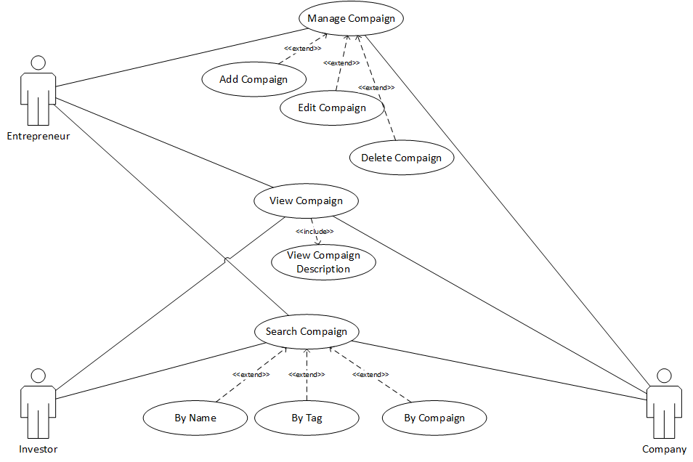

Figure 5: UC – Campaign

#### UC02: Add Campaign

|  |  |  |
| --- | --- | --- |
| **ID :** 002 | | **Name :** Add campaign |
| **Priority** | High | |
| **Actors** | Entrepreneurs | |
| **Summary** | User will add an idea or project campaign for investments. | |
| **Precondition** | User will be the member of platform and in mode of entrepreneurs. | |
| **Normal Flow of Events** | | **Alternative Path** |
| Entrepreneurs first enter the name of project and idea. Put some information about projects. | |  |
| Enter deadline of collection or share deadline | |  |
| Also add some constraint about project share and investment | |  |
| User will enter the add | |  |
| **Post Conditions** | | |
| Campaign will be posted on platform publically. In addition, add in user record database. | | |
| **References** | | |
| **Includes** |  | |
| **Extends** | Manage Campaign | |
| **Exceptions:** | | |
| Same type of campaign from one id will give duplication error. | | |

#### UC03: Edit Campaign

|  |  |  |
| --- | --- | --- |
| **ID :** 003 | | **Name :** Edit Campaign |
| **Priority** | High | |
| **Actors** | Entrepreneurs | |
| **Summary** | User can edit its campaign. | |
| **Precondition** | Campaign must be exist for editing. | |
| **Normal Flow of Events** | | **Alternative Path** |
| First user will select the campaign. | |  |
| User can edit the description of project | |  |
| User Click on Editing confirm button | |  |
| **Post Conditions** | | |
| Campaign content will be edited and updated in record of database. | | |
| **References** | | |
| **Includes** |  | |
| **Extends** | Manage Campaign | |
| **Exceptions:** | | |
| If user will edit the price or share content then exception will if any investor invest money. | | |

#### UC04: Delete Campaign

|  |  |  |
| --- | --- | --- |
| **ID :** 004 | | **Name :** Delete Campaign |
| **Priority** | High | |
| **Actors** | Entrepreneurs | |
| **Summary** | User will delete campaign which have no investments | |
| **Precondition** | Campaign will be exist and no investments on it. | |
| **Normal Flow of Events** | | **Alternative Path** |
| Entrepreneurs first select campaign | |  |
| After that user will check no investment on that campaign. | |  |
| Click on delete button | |  |
| **Post Conditions** | | |
| Campaign will be deleted from user console. Also deleted from record of database. | | |
| **References** | | |
| **Includes** |  | |
| **Extends** | Manage Campaign | |
| **Exceptions:** | | |
| If any investment on that project will be exist then exception will be rise. | | |

#### UC05: View Campaign

|  |  |  |
| --- | --- | --- |
| **ID :** 005 | | **Name :** View Campaign |
| **Priority** | High | |
| **Actors** | Entrepreneurs, Investor, Company | |
| **Summary** | User will view campaign and read investment policy that set by entrepreneurs. | |
| **Precondition** | Campaign will be exist. | |
| **Normal Flow of Events** | | **Alternative Path** |
| User select or click on campaign | |  |
| After that user will read project idea and policy description about project. | |  |
| User will also read comment about project | |  |
| **Post Conditions** | | |
| User will view campaign and after that may be they will have interest and invest on that project | | |
| **References** | | |
| **Includes** | View Campaign description | |
| **Extends** |  | |
| **Exceptions:** | | |
| After view that may be user interested to invest but no share will be available and exception will be raise. | | |

#### UC06: Search Campaign

|  |  |  |
| --- | --- | --- |
| **ID :** 006 | | **Name :** Search Campaign |
| **Priority** | High | |
| **Actors** | Entrepreneurs, Investors and Company | |
| **Summary** | User will search project or idea according to interest | |
| **Precondition** | User must be logged in | |
| **Normal Flow of Events** | | **Alternative Path** |
| The use case will be start when user will be on home page | |  |
| The User will enter the query in search bar. | |  |
| Click on search button | | User will be enter valid query then page display otherwise display error message. |
| **Post Conditions** | | |
| Now the user is able to view what he visions for. | | |
| **References:** | | |
| **Includes** |  | |
| **Extends** | By Tag, By name, by campaign | |
| **Exceptions:** | | |
| If user enter invalid project name then exception will be rise | | |

### Profile

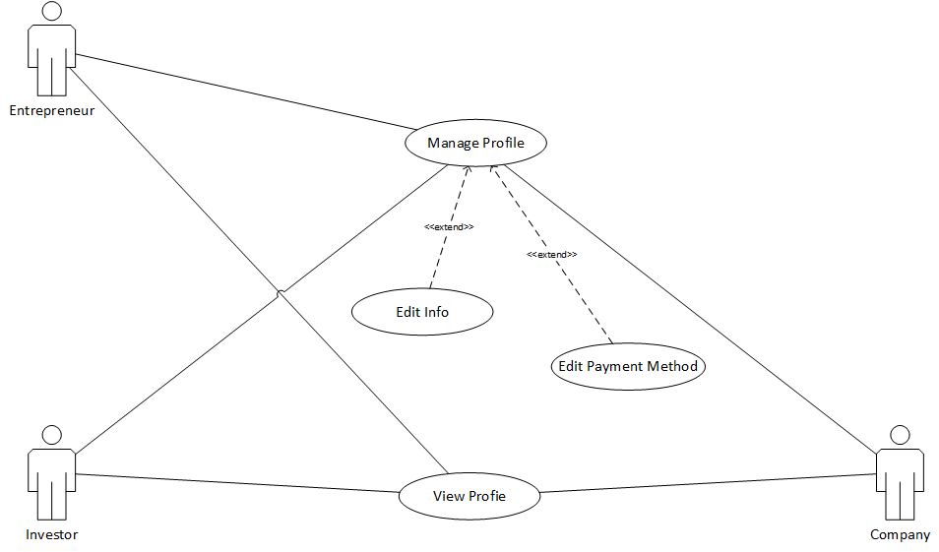

Figure 6: UC – Profile

#### UC07: View Profile

|  |  |  |
| --- | --- | --- |
| **ID :** 007 | | **Name :** View Profile |
| **Priority** | High | |
| **Actors** | Entrepreneur ,Investor, Company | |
| **Summary** | User are able to view any profile. | |
| **Precondition** | User must be Logged in by their perspective accounts | |
| **Normal Flow of Events** | | **Alternative Path** |
| 1. User select the profile of User he want to view | |  |
| 2. The System displays non critical information to the User | |  |
| **Post Conditions** | | |
|  | | |
| **References** | | |
| **Includes** |  | |
| **Extends** |  | |
| **Exceptions:** | | |
|  | | |

#### UC08: Edit Profile

|  |  |  |
| --- | --- | --- |
| **ID :** 008 | | **Name :** Edit Profile |
| **Priority** | High | |
| **Actors** | Entrepreneur ,Investor, Company | |
| **Summary** | User are able to edit their profile. | |
| **Precondition** | User must be Logged in by their perspective accounts | |
| **Normal Flow of Events** | | **Alternative Path** |
| 1.The User click on edit profile | |  |
| 2. The System Shall displays the Information that can edited. | |  |
| 3. The User Save the Information | | 3a. The User do not save the Information |
| **Post Conditions** | | |
| The Updated Information is Saved in Database | | |
| **References** | | |
| **Includes** |  | |
| **Extends** | Manage Profile | |
| **Exceptions:** | | |
|  | | |

Figure 7: UC – Login

### Investment

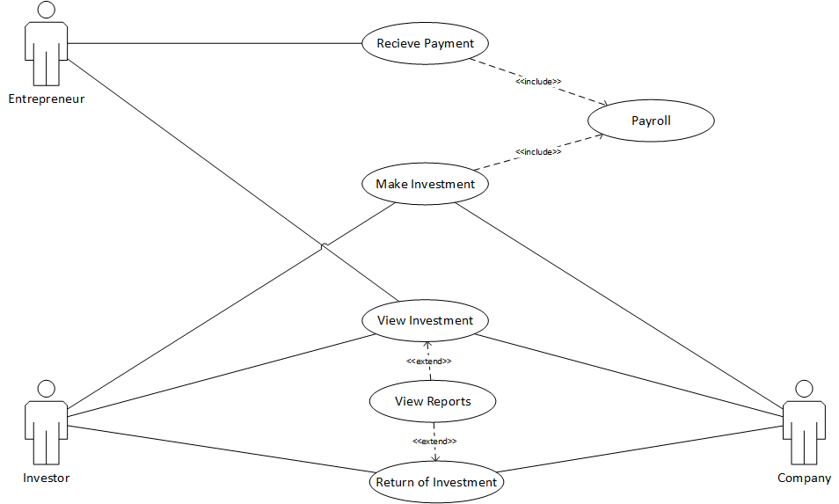

Figure 8: UC – Investment

#### UC09: Make Investment

|  |  |  |
| --- | --- | --- |
| **ID :** 009 | | **Name** **:** Make Investment |
| **Priority** | High | |
| **Actors** | Investor, Company | |
| **Summary** | User are able to make investment on the Campaign | |
| **Precondition** | User must select the Campaign they want to invest in | |
| **Normal Flow of Events** | | **Alternative Path** |
| User click on make investment button | |  |
| The system shall take the User to Payroll System | |  |
| The Notification of Investment is Received by Investor or Company | |  |
| **Post Conditions** | | |
|  | | |
| **References** | | |
| **Includes** | Payroll | |
| **Extends** |  | |
| **Exceptions:** | | |
|  | | |

#### UC10: View Investment

|  |  |  |
| --- | --- | --- |
| **ID :** 010 | | **Name :** View Investment |
| **Priority** | Moderate | |
| **Actors** | Entrepreneur ,Investor, Company | |
| **Summary** | User are able to view investment on all Campaign they make or receive. | |
| **Precondition** | The User make or receive an investment | |
| **Normal Flow of Events** | | **Alternative Path** |
| User click on View investment button | |  |
| The system shall display a list of all the investment they receive or make on their account | |  |
| The User select the make report to download the report of the investments | | The User do not select the make report to download the report of the investments |
| **Post Conditions** | | |
|  | | |
| **References** | | |
| **Includes** |  | |
| **Extends** |  | |
| **Exceptions:** | | |
|  | | |

#### UC11: Receive Investment

|  |  |  |
| --- | --- | --- |
| **ID :** 011 | | **Name :** Receive Investment |
| **Priority** | High | |
| **Actors** | Entrepreneur , Company | |
| **Summary** | The User Shall Receive The Payment on their Campaign | |
| **Precondition** | The User make an investment on Campaign | |
| **Normal Flow of Events** | | **Alternative Path** |
| 1. Payroll System return the details on the investment | |  |
| 2. User receive the information of the investment and Investment | |  |
| **Post Conditions** | | |
| Email is Generated for the Entrepreneur and Company | | |
| **References** | | |
| **Includes** | Payroll | |
| **Extends** |  | |
| **Exceptions:** | | |
|  | | |

### Payroll

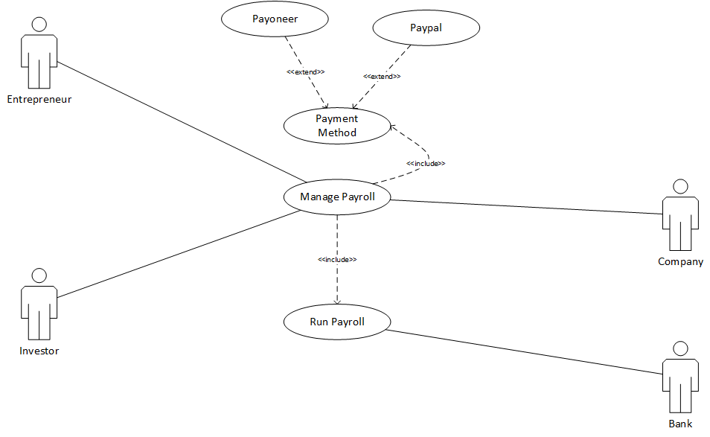

Figure 9: UC – Payroll

#### UC12: Manage Payroll

|  |  |  |
| --- | --- | --- |
| **ID :** 012 | | **Name :** Manage payroll |
| **Priority** | High | |
| **Actors** | Entrepreneur ,Investor, Company | |
| **Summary** | User will be able to make investment or receive payment through payroll system | |
| **Precondition** | User mush have selected the campaign where investment happens | |
| **Normal Flow of Events** | | **Alternative Path** |
| 1. User have selected the campaign where investment needed. | |  |
| 2.user will select the payment method of PayPal to make or receive investment | | 2a. user will select the payment method of Payoneer to make or receive investment |
| 3.User will provide account information | |  |
| 4. the information will be sent to bank for validation | |  |
| **Post Conditions** | | |
| After validating the payroll method, the investment will be happened. | | |
| **References** | | |
| **Includes** | Payment method | |
| **Extends** | PayPal , Payoneer | |
| **Exceptions:** | | |
| If user provide wrong information, the user will not be able to get payment or receive payment | | |

#### UC13: Run Payroll

|  |  |  |
| --- | --- | --- |
| **ID :** 013 | | **Name :** Run payroll |
| **Priority** | Medium | |
| **Actors** | Bank | |
| **Summary** | Bank will validate the user’s account information | |
| **Precondition** | User mush have sent the account information to the bank | |
| **Normal Flow of Events** | | **Alternative Path** |
| 1. User have selected the campaign where investment needed and provide information. | |  |
| 2.The information will be sent to bank for validation | |  |
| 3.Bank related PayPal will verify the account information | | 3a.Bank related Payoneer will verify the account information |
| 4. User will investment or receive payment | |  |
| **Post Conditions** | | |
| After validating the payroll method ,user can be able to get or receive payment | | |
| **References** | | |
| **Includes** |  | |
| **Extends** |  | |
| **Exceptions:** | | |
| If user provide wrong information, the bank will notify the user that provided information is wrong | | |

### Conservation

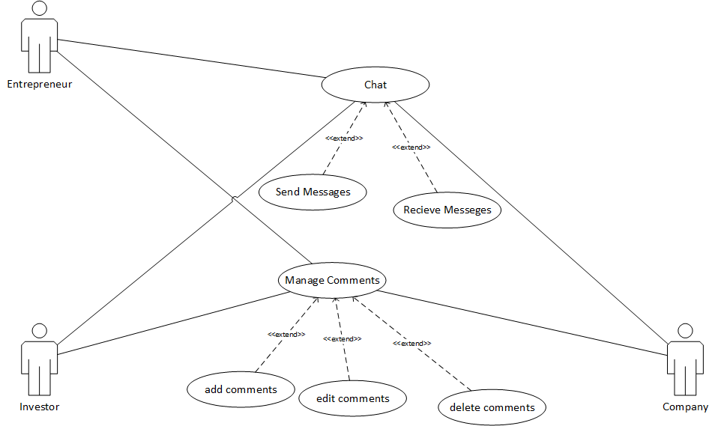

Figure 10: UC – Conversation

#### UC14: Manage Comments

|  |  |  |
| --- | --- | --- |
| **ID :** 014 | | **Name :** Manage Comments |
| **Priority** | High | |
| **Actors** | Entrepreneur ,Investor, Company | |
| **Summary** | User can chat to make comments about any campaign where general info required | |
| **Precondition** | User mush have selected the campaign where he want to comment | |
| **Normal Flow of Events** | | **Alternative Path** |
| 1.User will add the comment at campaign | |  |
| 2.User can edit the comment at that campaign | | 2a. User can delete the comment at that campaign |
| 3. Other user will receive notification for the comment | |  |
| 4. Other user will view the comment | |  |
| 5-Other user will reply the comment | |  |
| **Post Conditions** | | |
| After sending /receiving the message, user will be notified message has been sent /receive | | |
| **References** | | |
| **Includes** |  | |
| **Extends** | Add comments, edit comments, delete comments | |
| **Exceptions:** | | |
|  | | |

#### UC15: Chat

|  |  |  |
| --- | --- | --- |
| **ID :** 015 | | **Name :** Chat |
| **Priority** | High | |
| **Actors** | Entrepreneur ,Investor, Company | |
| **Summary** | User can chat to make discussion about campaign or send/receive file | |
| **Precondition** | User mush have selected the chat box | |
| **Normal Flow of Events** | | **Alternative Path** |
| 1.User will select the other user to send message | |  |
| 2.User will write the message to send | | 2a.User will send the file |
| 3. Other user will receive notification for the message | | 3a. Other user will receive the file |
| 4. Other user will receive the message | |  |
| **Post Conditions** | | |
| After sending /receiving the message, user will be notified message has been sent /receive | | |
| **References** | | |
| **Includes** |  | |
| **Extends** | Send message, receive message | |
| **Exceptions:** | | |
| If user will send the message ,but failed due to wrong type of message | | |

### Notification

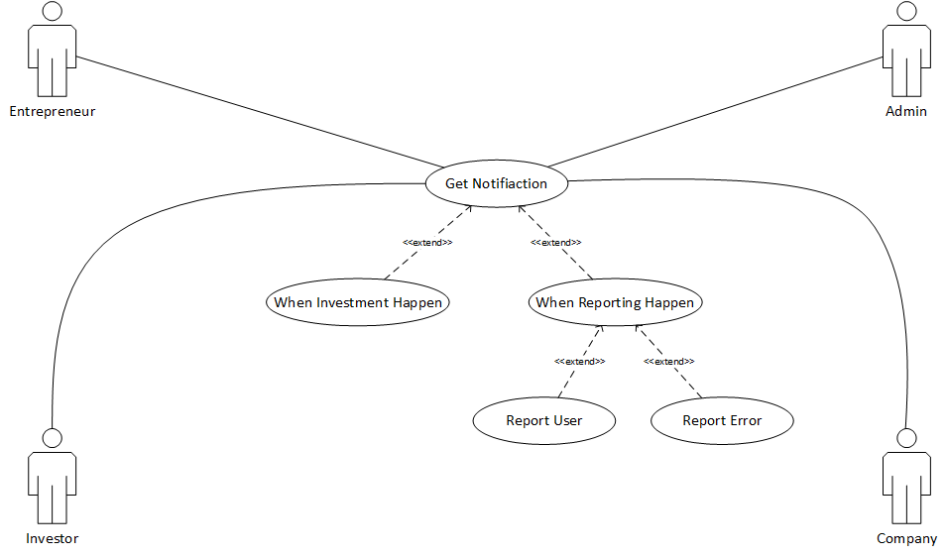

Figure 11: UC – Notification

#### UC16: Get Notification

|  |  |  |
| --- | --- | --- |
| **ID :** 016 | | **Name :** Get Notification |
| **Priority** | High | |
| **Actors** | Entrepreneur ,Investor, Company, Admin | |
| **Summary** | After completion of any activity, a notification will be sent to all related users. | |
| **Precondition** | User mush have completed activity where he want to be notified | |
| **Normal Flow of Events** | | **Alternative Path** |
| 1.User will get notification when any other user comment | | 1a. User will get notification when any other user send message |
| 2. User will get notification when investment happens | | 2a.User will get notification when payment receives |
| 3. Admin will get notification when any user report other user | | 3a. Admin will get notification when any user report bugs |
| **Post Conditions** | | |
| After getting notification ,user will do task related to that notification | | |
| **References** | | |
| **Includes** |  | |
| **Extends** | Report user, report bugs | |
| **Exceptions:** | | |
| If user will not get notification if he is not logged in. | | |

### Login

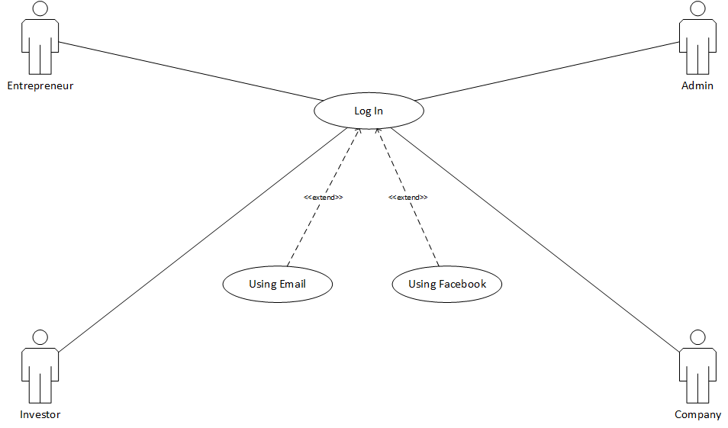

Figure 12: UC – Login

#### UC17: Login

|  |  |  |
| --- | --- | --- |
| **ID :** 017 | | **Name :** Get Notification |
| **Priority** | Medium | |
| **Actors** | Entrepreneur , Investor , Company | |
| **Summary** | User will be able to login to the application (Android and Web) | |
| **Precondition** | User should be registered. | |
| **Normal Flow of Events** | | **Alternative Path** |
| 1. User will enter username and password in the field provided | |  |
| 2. User will click on the login button | | 2a. If the login details are wrong user will get the error message that credential details are wrong.  2b. System will also offer the “forget details” option to reset them. |
| 3-User can log in by Email or Facebook | |  |
| **Post Conditions** | | |
| After getting notification ,user will do task related to that notification | | |
| **References:** | | |
| **Includes** |  | |
| **Extends** | Report user, report bugs | |
| **Exceptions:** | | |
| If user will not get notification if he is not logged in. | | |

## Software Development Life Cycle Model

The software development life cycle model, also known as creation cycle for an application used in information and engineering systems, to describe the planning, analysis, design, implementation, testing and maintenance of processes. These concepts are also applying in software as well as hardware applications as we know that the system is the combination of software, hardware or both.

Our SDLC is Waterfall Model with Rapid Prototyping**:**

We are going to use a mix of Waterfall Model with Rapid Prototyping.

### Why use Waterfall Model?

It is used when the requirements are clear, product description is sure and tools and technology is known.

### Why use Rapid Prototyping Model?

It is used where customers are non-technical and usually do not know what they want and what they can have.

Due to unclear requirements of what will be easy for the users and moderate chances of requirement changes, we will use prototyping model to provide users with prototypes and they will update our prototypes, which will help us in clearing our requirements according to those feedbacks provided by the users, until all requirements are captured and are cleared.

Then we will use waterfall model to implement those requirements. Because waterfall model needs clear requirements, the clear requirements will be taken to start the waterfall phases. In waterfall model, we get a complete document at the end of a phase to verify that all the requirements are implemented according to requirement plan. Because of these documents, maintenance of app becomes easy.

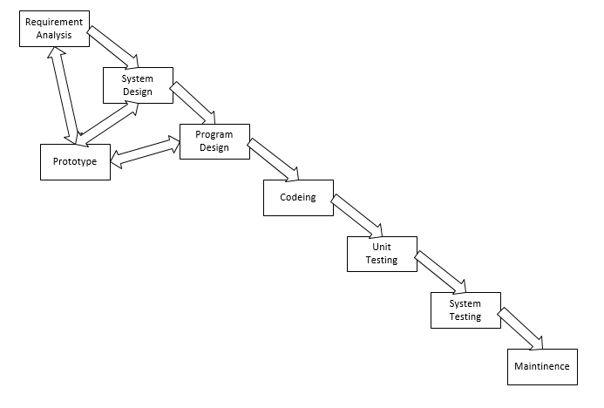

Figure 13: Proposed SDLC Hybrid Model

# System Design

Systems design is the practice of identify the system structure (architecture), its components and information for a system to fulfil the given requirements. Systems design can be represented as system development. It contains different type of diagrams like activity diagram, sequence diagram, database diagram, class diagram, system architecture and collaboration diagrams.

## Work Breakdown Structure (WBS)

A work breakdown structure is a representation of deliverables of team's work into manageable sections. WBS is hierarchal description of software developments life cycle or software development phases. It tells about how your system modules are classified and how they will be completed in given order. The WBS provides the foundation for all project management work.

It is important because it makes the deliverables cleaner and precise so that the project team can easily understand what has to be accomplished in each deliverable.

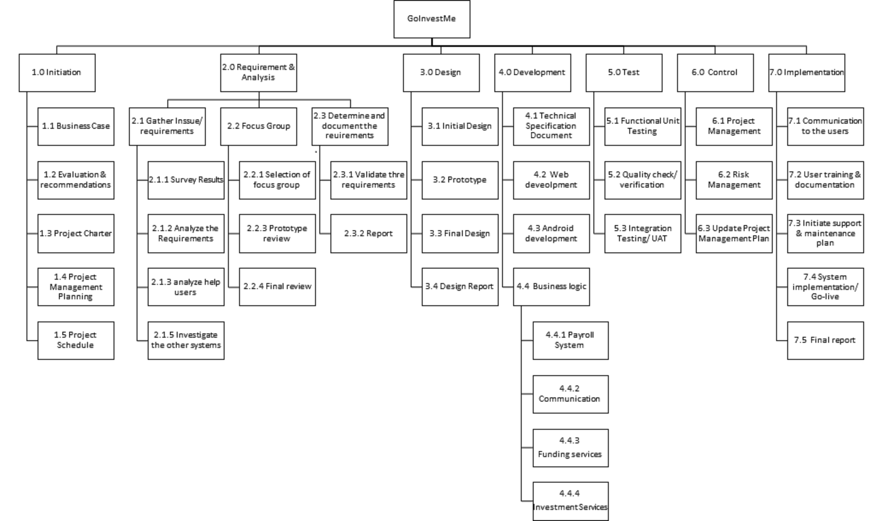

Figure 14: Work Breakdown Structure

## Activity Diagram

Activity diagram is used to describe the different features of the system in UML (unified modelling language). Activity diagram is like a flowchart to show the order from one feature to another feature. These features can be called activities. The activity can be called as an action of the system. The control order is described as from one action to another.

It is important because it is flow from one activity to another activity but in different diagrams, the flow is from one object to another object.

### Sign Up

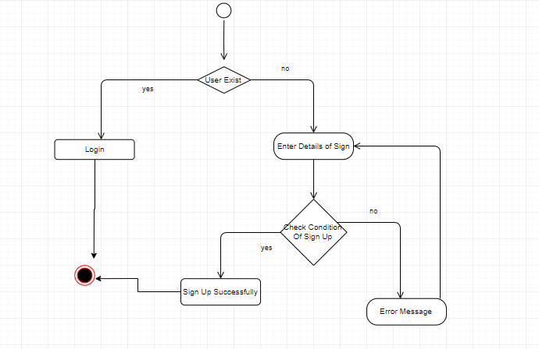

Figure 15: AD – Sign Up

### Add Campaign

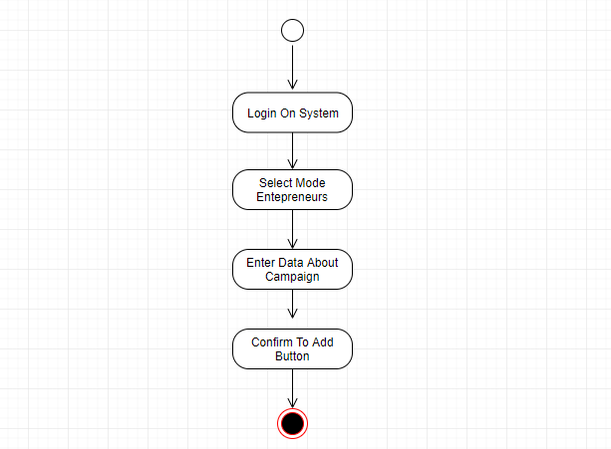

Figure 16: AD – Add Campaign

### Edit Campaign

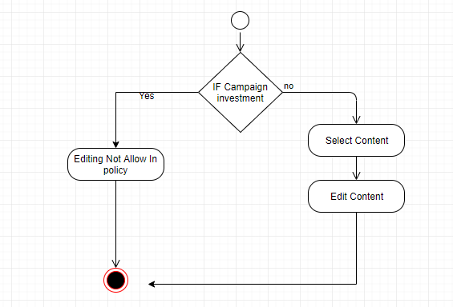

Figure 17: AD – Edit Campaign

### Delete Campaign

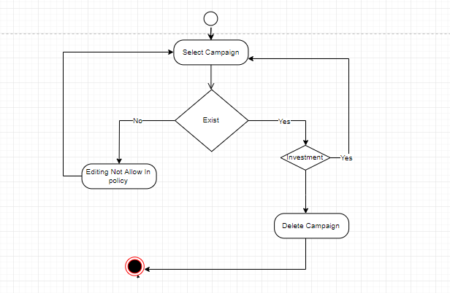

Figure 18: AD – Delete Campaign

### Search

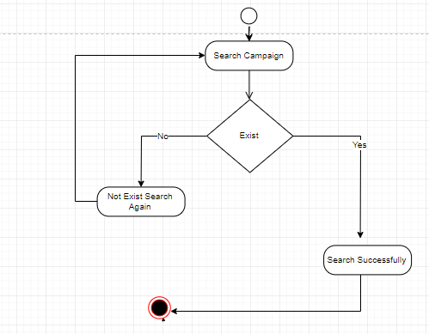

Figure 19: AD – Search

### View Profile

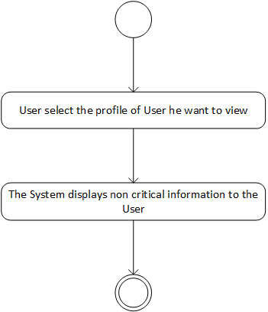

Figure 20: AD – View Profile

### Edit Profile

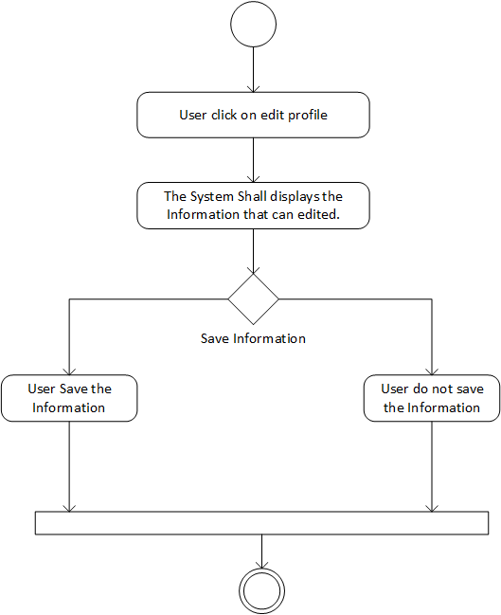

Figure 21: AD – Edit Profile

### Make Investment

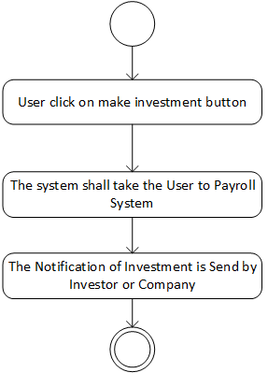

Figure 22: AD – Make Investment

### View Investment

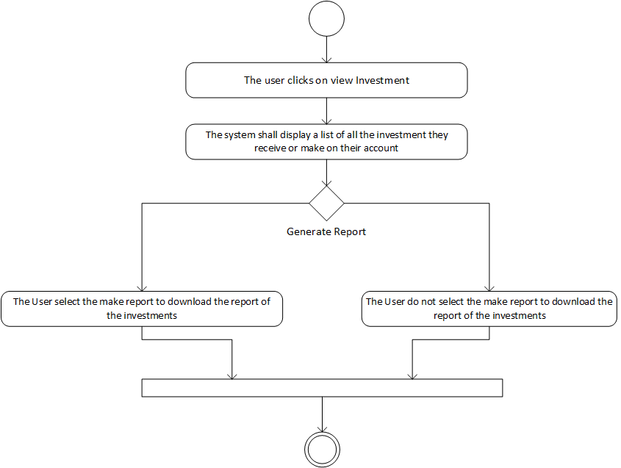

Figure 23: AD – View Investment

### Receive Investment

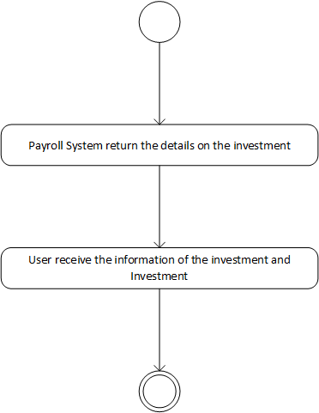

Figure 24: AD – Receive Investment

### Manage Payroll

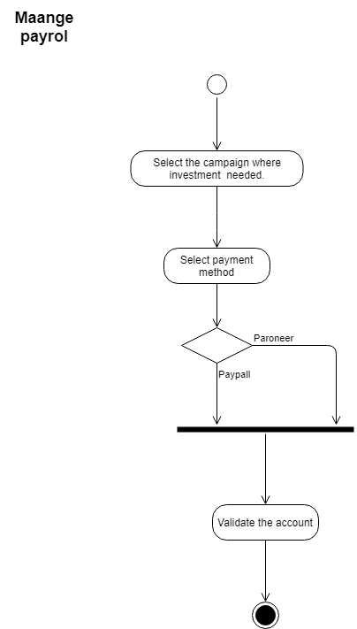

Figure 25: AD – Manage Payroll

### Manage Comments

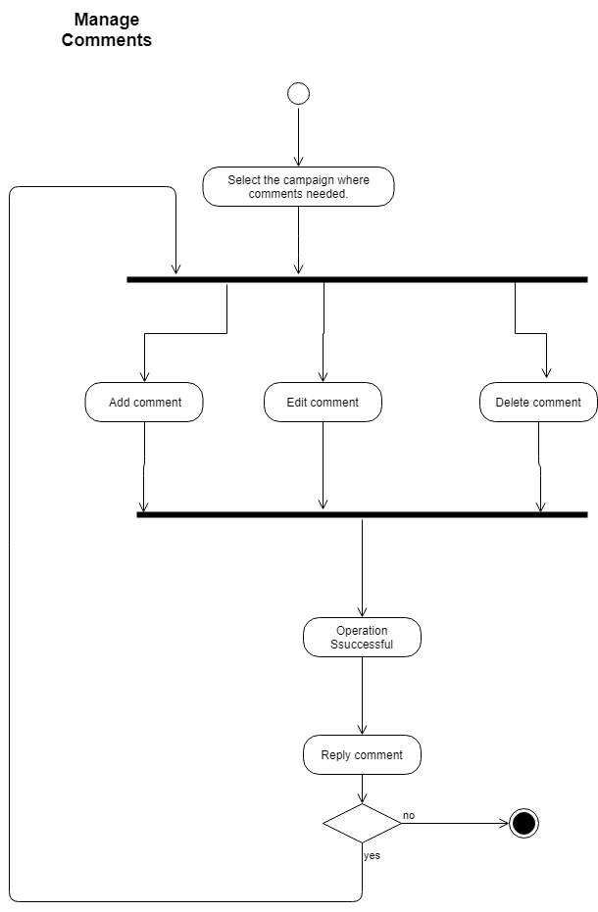

Figure 26: AD – Manage Comments

### Chatting

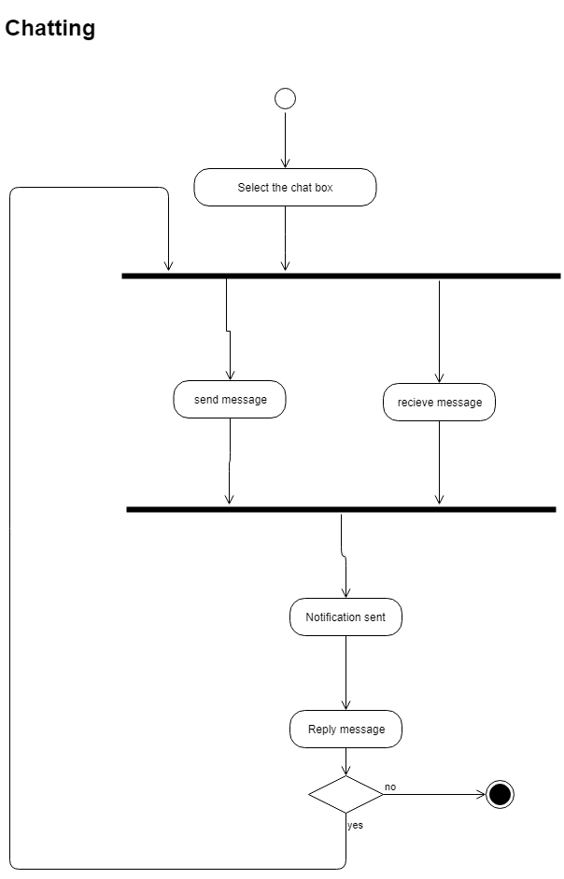

Figure 27: AD – Chatting

### Notification

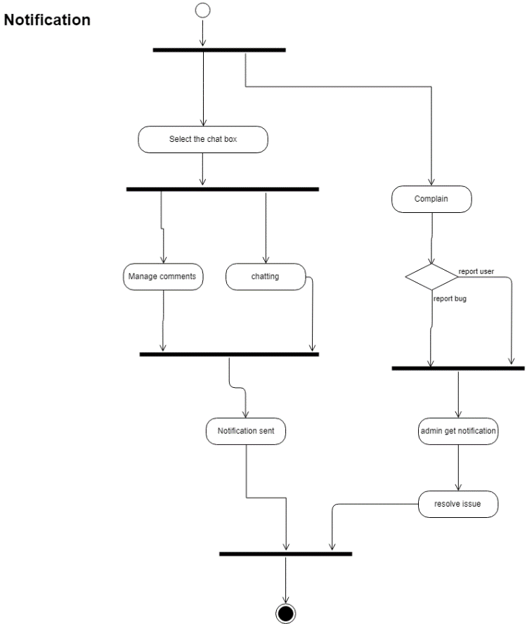

Figure 28: AD – Notification

### Login

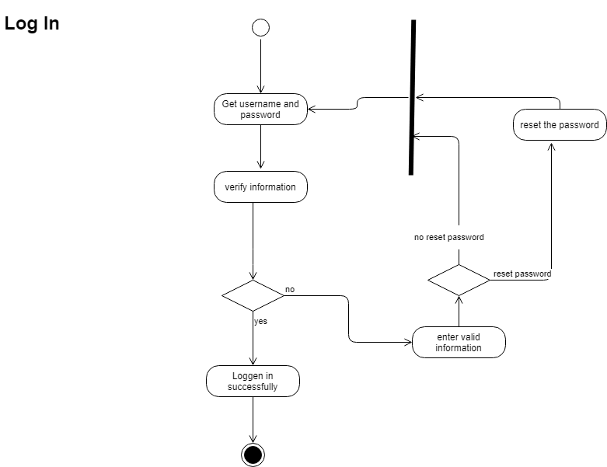

Figure 29: AD – Login

### Run Payroll

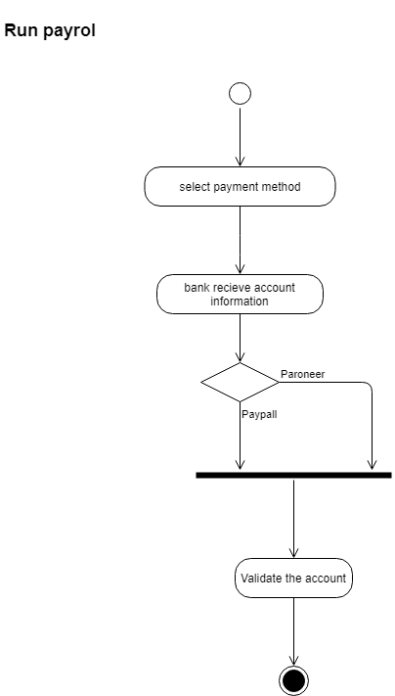

Figure 30: AD – Run Payroll

## Sequence Diagram

Sequence diagrams are also defined as event scenarios. A sequence diagram display, as corresponding vertical lines, different actors and modules that linked with horizontal arrows, the communications replaced between them by maintaining the flow.

It is important because it is used to describe software requirements and to ensure a system's design. Why it is useful because it shows the communication logic between the actors and modules in the time that the communication occurs.

### Chatting

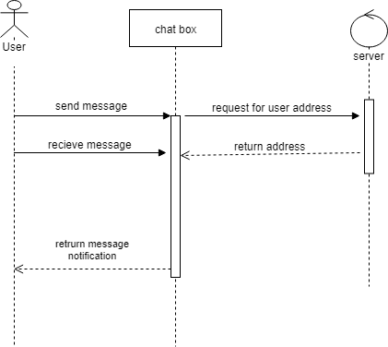

Figure 31: SD – Chatting

### Feedback

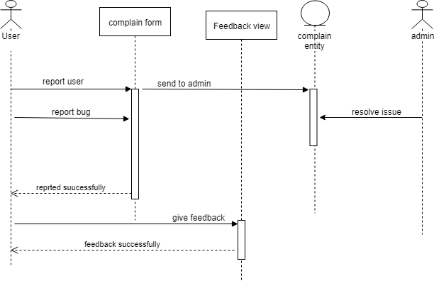

Figure 32: SD – Feedback

### Comments

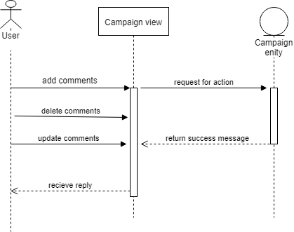

Figure 33: SD – Comments

### Make Investment

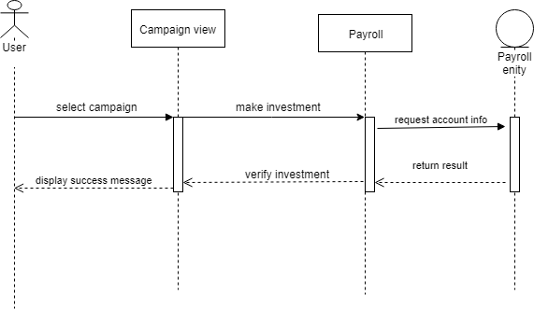

Figure 34: SD – Make Investment

### Receive Investment

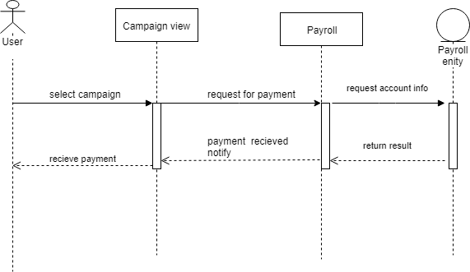

Figure 35: SD – Receive Investment

### Sign Up and Login

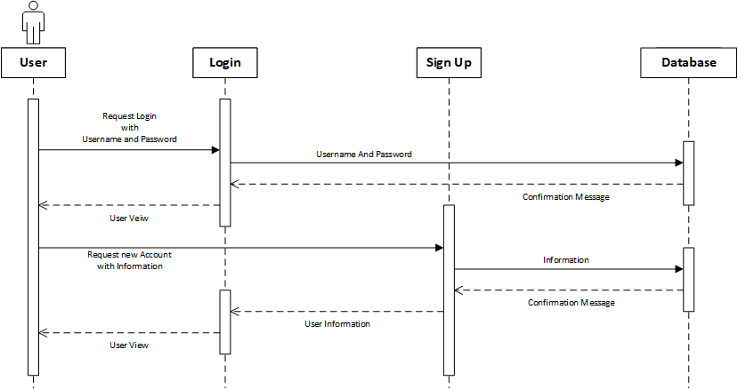

Figure 36: SD – Sign Up and Login

### Profile

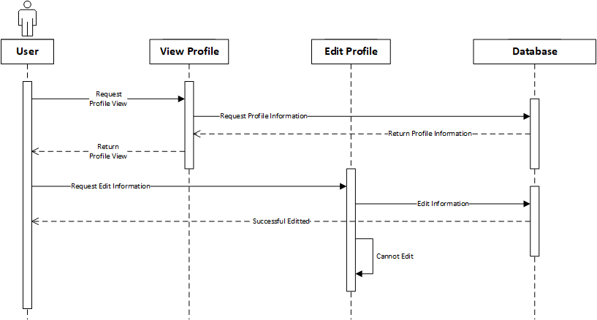

Figure 37: SD – Profile

### Campaign

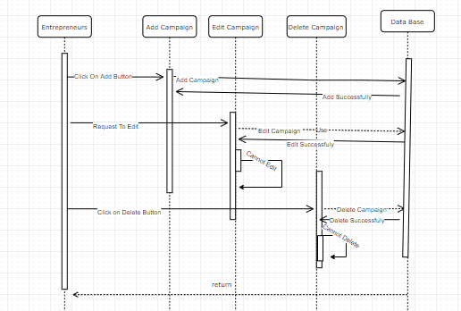

Figure 38: SD – Campaign

### Search and View Campaign

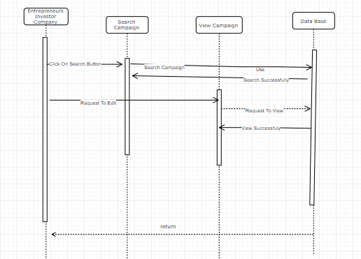

Figure 39: SD – Search and View

## Software Architecture

Software architecture is representation of functional structures of a system and the discipline of making structures and systems. Every structure includes software modules, links between them, and characteristics of both modules and links.

### MVC Architecture

The software architecture, which we are using, is MVC stand for Model View Controller.

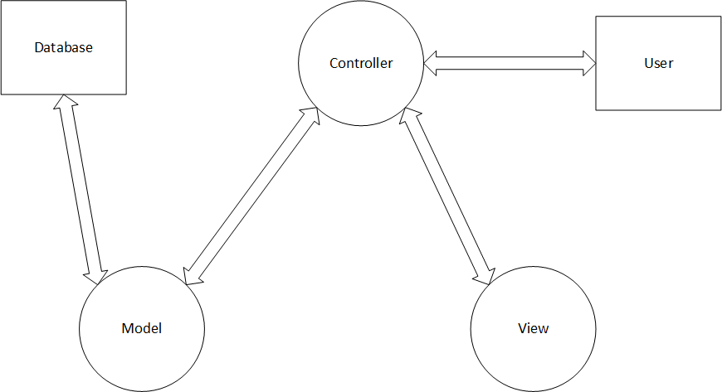

Figure 40: MVC Architecture

GoInvestMe A crowdfunding platform for start-ups is a huge system, which is based on web-application and android created for Entrepreneurs and Investors. This system records all campaigns, entrepreneur, investor, and company information etc. Our project is based on MVC architecture with ability to take large number of data.

The model view controller (MVC) architecture is used to implement interfaces. MVC is a famous choice for web apps.it separates the logic in three parts i.e. model, view and controller. The model will inform the view to update its display according to data as it contains the data that app should use. In our project, the model will specify what data the interfaces should contain that campaigns interface, user’s interface and category’s interface and it will inform the view to update display according to the changes that has occurred. The controller will handle all the logic that updates view and model in reply to input from the users. Our project could have input buttons and forms to add delete and edit information from their profiles, in registration etc.

Our project data model will be contained in database (SQL Server) our applications controlling code will be written in java script and interfaces will be written using CSS/HTML. This is similar to MVC.

This separation of responsibilities in MVC architecture will help to make our project more flexible, secure and will increase performance.

## Class Diagram

Class diagram in the Unified Modelling Language tells about architecture of a software system by presenting classes, their characteristics, methods, and objects. The relationships can be one to one, one to many, many to many between different classes.

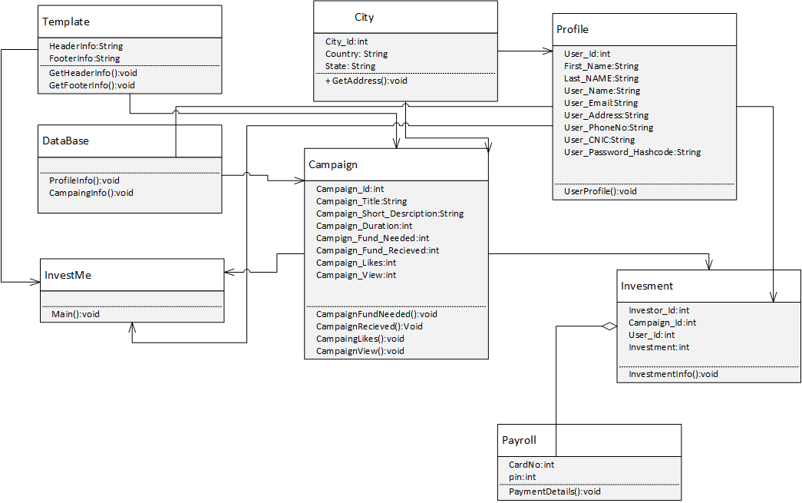

Figure 41: Class Diagram

## Database Diagram

Database diagram is also called entity relationship diagram. It tells about the relations between schemas. A database schema is the designs of your database; it represents the description of a database structure, data types, and the restrictions on that database. It is important step to start developing any software by designing database schemas.

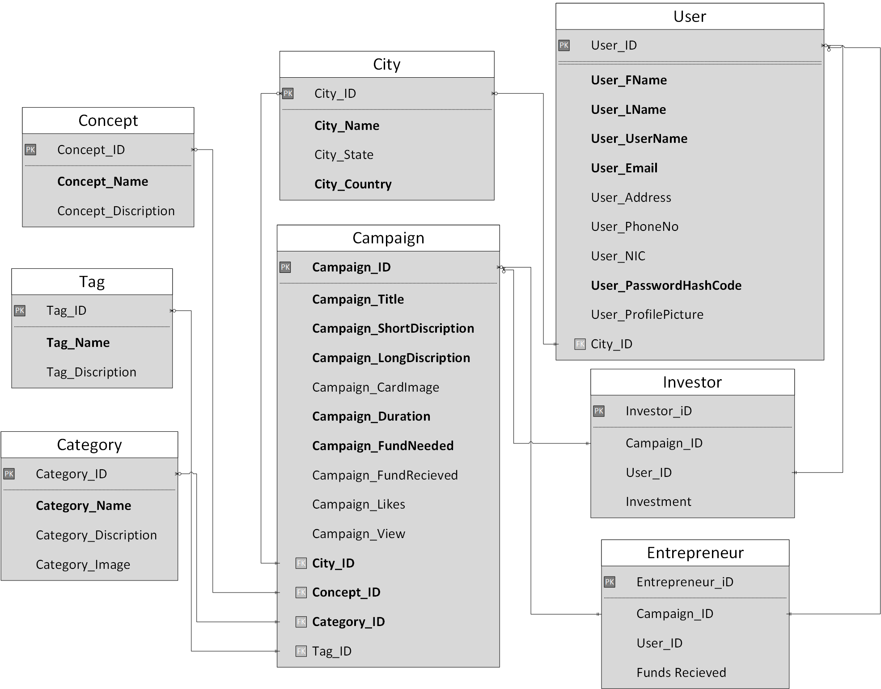

Figure 42: ERD – Database Diagram

## Network Diagram (Gantt chart)

 A Gantt chart is a tool used for project management. It can be used to signify the timing of several jobs that are essential to fulfil a project requirement. A network diagram describes the several jobs of project in sequential flow by connecting links.

. Gantt chart is important because it tells about how much time is required to complete this phase and which team will complete it.

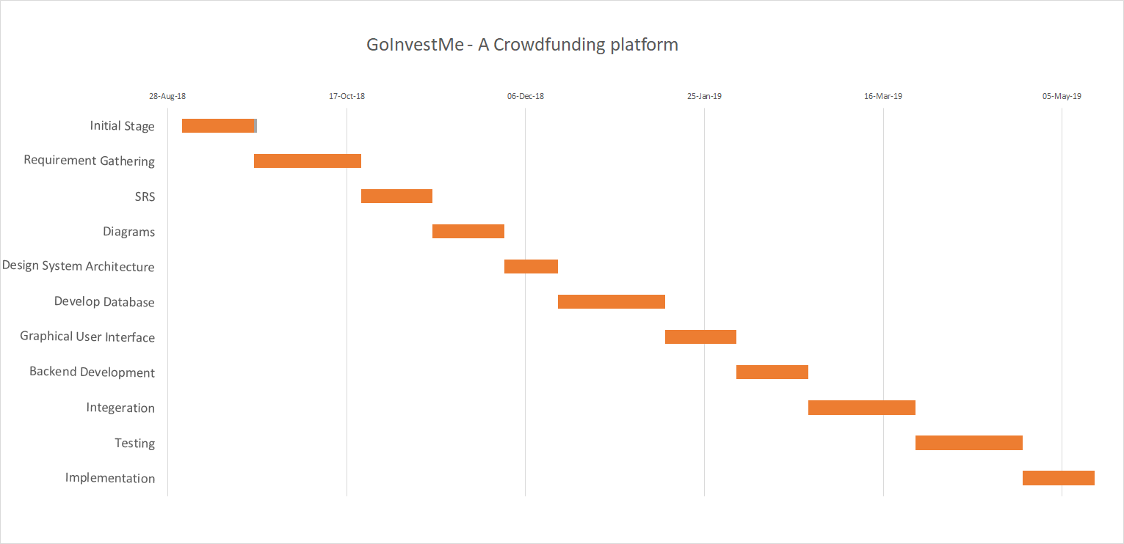

Figure 43: Gantt Chart

## Collaboration Diagram

A collaboration diagram is sometime called communication or interaction diagram, is a representation of the relationships and interactions among software objects in Unified Modelling Language. Every sequence diagram will have collaboration diagram. It helps the developer to understand the communication between different modules.

### Chatting

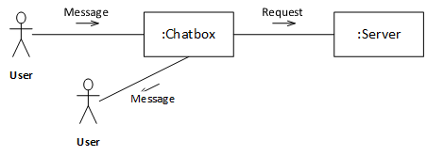

Figure 44: CD – Chatting

### Feedback

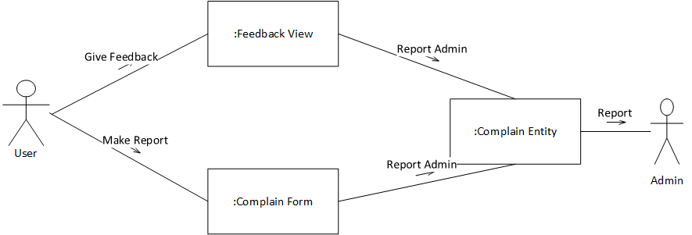

Figure 45: CD – Feedback

### Make Investment

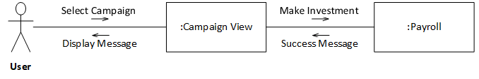

Figure 46: CD – Make Investment

### Receive Investment

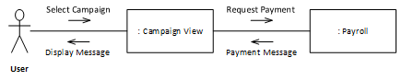

Figure 47: CD – Receive Investment

### Sign Up and Login

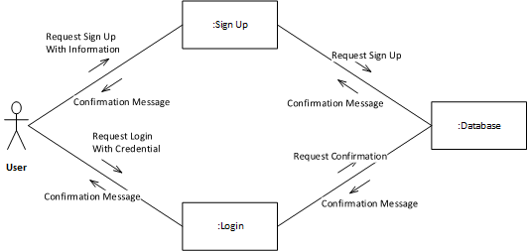

Figure 48: CD – Sign Up & Login

### Profile

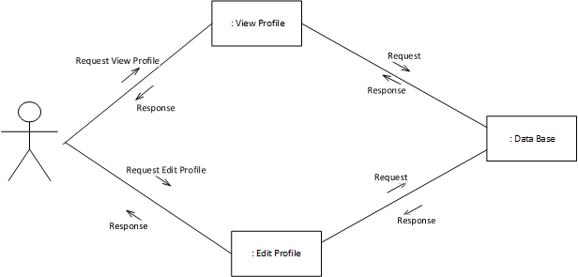

Figure 49: CD – Profile

### Campaign

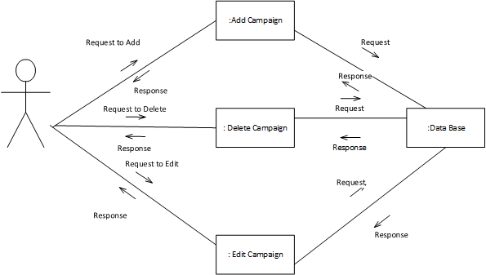

Figure 50: CD – Campaign

### Search and View Campaign

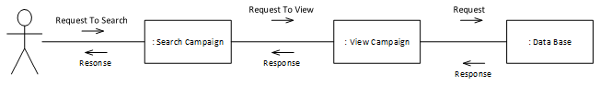

Figure 51: CD – Search and View Campaign

# System Testing

System Testing is the testing of fully integrated and complete system project. When all the tested modules are gathered and testing is performed that is called system testing. Eventually, software is interacted with other software/hardware systems.

Two types of Software Testing

* White Box
* Black Box

System test is actually black box testing.

White box testing is used for testing the internal structure or code of a software. However, black box or System Testing is used for testing the external structure of the software system from the user's viewpoint.

## Test Cases

A test case is a description of the user inputs, implementing conditions, testing requirement, and estimated results that express a single test to be implemented to achieve a particular software-testing module. It can be following the path in which test case execute in some order. Test cases is actually representation of every requirement that is to be implemented.

### TC-01: Sign Up

|  |  |  |  |  |  |  |  |
| --- | --- | --- | --- | --- | --- | --- | --- |
| Overview | | | | | | | |
| **ID** | | 01 | | **Name** | | Sign Up | |
| **Application** | | GoInvestMe – A Crowdfunding platform | | **Priority** | | High | |
| Description | | Before using this platform functionality , first user will be sign up on this platform | | | | | |
| Assumption | | Client will enter information | | | | | |
| **Pre-Condition** | | | | | | | |
| Client has valid information | | | | | | | |
| **Steps** | **Test Steps** | | **Test Data** | **Expected Result** | **Actual Result** | | **Status** |
| 1. | Insert data in require field | | Fill the sign up details according to policy | 1)Sign up successfully  2) Incomplete details again sign up | Sign up successfully | | pass |
| **Post-Condition** | | | | | | | |
| User will be registered in this platform. Data base will be updated | | | | | | | |

### TC-02: Add Campaign

|  |  |  |  |  |  |  |  |
| --- | --- | --- | --- | --- | --- | --- | --- |
| Overview | | | | | | | |
| **ID** | | 02 | | **Name** | | Add Campaign | |
| **Application** | | GoInvestMe – A Crowdfunding platform | | **Priority** | | High | |
| Description | | User will add an idea or project campaign for investments. | | | | | |
| Assumption | | Client will add new campaign that he/she would not be add before | | | | | |
| **Pre-Condition** | | | | | | | |
| User will be the member of platform and in mode of entrepreneurs. | | | | | | | |
| **Steps** | **Test Steps** | | **Test Data** | **Expected Result** | **Actual Result** | | **Status** |
| 1. | Enter valid data for campaign | | Pick Information is valid, how many data is plagiarism | 1)Campaign add successfully  2) Campaign is already add | Campaign added successfully | | pass |
| **Post-Condition** | | | | | | | |
| Same type of campaign from one id will give duplication error. | | | | | | | |

### TC-03: Edit Campaign

|  |  |  |  |  |  |  |  |
| --- | --- | --- | --- | --- | --- | --- | --- |
| Overview | | | | | | | |
| **ID** | | 03 | | **Name** | | Edit Campaign | |
| **Application** | | GoInvestMe – A Crowdfunding platform | | **Priority** | | High | |
| Description | | User can edit its campaign. | | | | | |
| Assumption | | Client will edit its content that is related to campaign. | | | | | |
| **Pre-Condition** | | | | | | | |
| Campaign must be exist for editing. | | | | | | | |
| **Steps** | **Test Steps** | | **Test Data** | **Expected Result** | **Actual Result** | | **Status** |
| 1. | First user will select campaign | | Not edit those campaign policy that have some investment | 1)Campaign Edit Successfully  2) Not edit campaign | Campaign edit successfully | | pass |
| **Post-Condition** | | | | | | | |
| Campaign content will be edited and updated in record of database. | | | | | | | |

### TC-04: Delete Campaign

|  |  |  |  |  |  |  |  |
| --- | --- | --- | --- | --- | --- | --- | --- |
| Overview | | | | | | | |
| **ID** | | 04 | | **Name** | | Delete campaign | |
| **Application** | | GoInvestMe – A Crowdfunding platform | | **Priority** | | High | |
| Description | | Entrepreneurs will delete campaign which have no investments | | | | | |
| Assumption | | Entrepreneurs can delete campaign | | | | | |
| **Pre-Condition** | | | | | | | |
| Campaign will be exist and no investments on it. | | | | | | | |
| **Steps** | **Test Steps** | | **Test Data** | **Expected Result** | **Actual Result** | | **Status** |
| 1. | First entrepreneur will select campaign f or delete | | Not delete those campaign that have some investment | 1)Campaign Delete Successfully  2) Not Delete campaign some constraint exist | Campaign delete successfully | | pass |
| **Post-Condition** | | | | | | | |
| Campaign will be deleted from user console. Also deleted from record of database. | | | | | | | |

### TC-05: View Campaign

|  |  |  |  |  |  |  |  |
| --- | --- | --- | --- | --- | --- | --- | --- |
| Overview | | | | | | | |
| **ID** | | 05 | | **Name** | | View campaign | |
| **Application** | | GoInvestMe- A Crowdfunding platform | | **Priority** | | High | |
| Description | | User will view campaign and read investment policy that set by entrepreneurs. | | | | | |
| Assumption | | All user can view campaign | | | | | |
| **Pre-Condition** | | | | | | | |
| Campaign will be exist. | | | | | | | |
| **Steps** | **Test Steps** | | **Test Data** | **Expected Result** | **Actual Result** | | **Status** |
| 1. | First entrepreneur will select campaign f or view | | Campaign policy  View content | 1)Campaign View Successfully  2) Not View campaign some constraint exist due to platform | Campaign view successfully | | pass |
| **Post-Condition** | | | | | | | |
| User will view campaign and after that may be they will have interest and invest on that project | | | | | | | |

### TC-06: Delete Campaign

|  |  |  |  |  |  |  |  |
| --- | --- | --- | --- | --- | --- | --- | --- |
| Overview | | | | | | | |
| **ID** | | 06 | | **Name** | | Search Campaign | |
| **Application** | | GoInvestMe - A Crowdfunding platform | | **Priority** | | High | |
| Description | | User will search project or idea according to interest | | | | | |
| Assumption | | User may recommend the project according to their interest, beyond the list. | | | | | |
| **Pre-Condition** | | | | | | | |
| User must be logged in | | | | | | | |
| **Steps** | **Test Steps** | | **Test Data** | **Expected Result** | **Actual Result** | | **Status** |
| 1. | User will click on search button and select campaign | | Campaign data will be select for testing | 1)Campaign Search Successfully  2) Not relate to any campaign. | Campaign view successfully | | pass |
| **Post-Condition** | | | | | | | |
| Project will be executed on the basis of the search | | | | | | | |

### TC-07: View Profile

|  |  |  |  |  |  |  |  |
| --- | --- | --- | --- | --- | --- | --- | --- |
| Overview | | | | | | | |
| **ID** | | 07 | | **Name** | | View Profile | |
| **Application** | | GoInvestMe – A Crowdfunding Platform | | **Priority** | | High | |
| Description | | User are able to view any profile. | | | | | |
| Assumption | | User has Logged in. | | | | | |
| **Pre-Condition** | | | | | | | |
| User must be Logged in by their perspective accounts | | | | | | | |
| **Steps** | **Test Steps** | | **Test Data** | **Expected Result** | **Actual Result** | | **Status** |
| 1 | Click on View Profile | |  | 1) The Profile which has been clicked on Show in the view | The Profile is Shown | | Pass |
| **Post-Condition** | | | | | | | |
|  | | | | | | | |

### TC-08: Edit Profile

|  |  |  |  |  |  |  |  |
| --- | --- | --- | --- | --- | --- | --- | --- |
| Overview | | | | | | | |
| **ID** | | 08 | | **Name** | | Edit Profile | |
| **Application** | | GoInvestMe – A Crowdfunding Platform | | **Priority** | | High | |
| Description | | User are able to Edit their profile. | | | | | |
| Assumption | | User has Logged in. | | | | | |
| **Pre-Condition** | | | | | | | |
| User must be Logged in by their perspective accounts | | | | | | | |
| **Steps** | **Test Steps** | | **Test Data** | **Expected Result** | **Actual Result** | | **Status** |
| 1 | Click on Edit Profile | | Fill the Profile Form according to the required information | 1)Profile Updated  2)Incorrect Information Entered | The Profile is Updated | | Pass |
| **Post-Condition** | | | | | | | |
| The Data in Database is updated | | | | | | | |

### TC-09: Make Investment

|  |  |  |  |  |  |  |  |
| --- | --- | --- | --- | --- | --- | --- | --- |
| Overview | | | | | | | |
| **ID** | | 09 | | **Name** | | Make Investment | |
| **Application** | | GoInvestMe – A Crowdfunding Platform | | **Priority** | | High | |
| Description | | User are able to make investment on the Campaign | | | | | |
| Assumption | | User has Logged in. | | | | | |
| **Pre-Condition** | | | | | | | |
| User must select the Campaign they want to invest in | | | | | | | |
| **Steps** | **Test Steps** | | **Test Data** | **Expected Result** | **Actual Result** | | **Status** |
| 1 | Click on make Investment Button | |  | 1) Go to the Payroll system | The Payroll System is in the view | | Pass |
| **Post-Condition** | | | | | | | |
| The Notification is send to the Investor | | | | | | | |

### TC-10: View Investment

|  |  |  |  |  |  |  |  |
| --- | --- | --- | --- | --- | --- | --- | --- |
| Overview | | | | | | | |
| **ID** | | 10 | | **Name** | | View Investment | |
| **Application** | | GoInvestMe – A Crowdfunding Platform | | **Priority** | | High | |
| Description | | User are able to view investment on all Campaign they make or receive. | | | | | |
| Assumption | | User has Logged in. | | | | | |
| **Pre-Condition** | | | | | | | |
| The User make or receive an investment | | | | | | | |
| **Steps** | **Test Steps** | | **Test Data** | **Expected Result** | **Actual Result** | | **Status** |
| 1 | Click on View Investment Button | |  | 1) List all the Investment of user in the investment view button | The Investment Page is in the view | | Pass |
| **Post-Condition** | | | | | | | |
|  | | | | | | | |

### TC-11: Receive Investment

|  |  |  |  |  |  |  |  |
| --- | --- | --- | --- | --- | --- | --- | --- |
| Overview | | | | | | | |
| **ID** | | 11 | | **Name** | | Receive Investment | |
| **Application** | | GoInvestMe – A Crowdfunding Platform | | **Priority** | | High | |
| Description | | User are able to view any profile. | | | | | |
| Assumption | | User has Logged in. | | | | | |
| **Pre-Condition** | | | | | | | |
| The U make an investment on Campaign | | | | | | | |
| **Steps** | **Test Steps** | | **Test Data** | **Expected Result** | **Actual Result** | | **Status** |
| 1 | Click on Notification button | | Data Coming from Payroll System about the Investment | 1) The Investment is shown | The Investment is Shown | | Pass |
| **Post-Condition** | | | | | | | |
| Email is Generated for the Entrepreneur and Company | | | | | | | |

### TC-12: Login

|  |  |  |  |  |  |  |  |
| --- | --- | --- | --- | --- | --- | --- | --- |
| Overview | | | | | | | |
| **ID** | | 12 | | **Name** | | Login | |
| **Application** | | GoInvestMe - A crowdfunding platform | | **Priority** | | High | |
| Description | | Registration for log in to the system. | | | | | |
| Assumption | | User has valid login details | | | | | |
| **Pre-Condition** | | | | | | | |
| User has opened login page | | | | | | | |
| **Steps** | **Test Steps** | | **Test Data** | **Expected Result** | **Actual Result** | | **Status** |
| 1 | Click on login button. | | Fill the registration form according to the required information. (First name,  Last name etc.) | 1) Login successful 2) Incomplete details; try again with valid and complete data. | Logged in successfully | | Pass |
| 2 | Click on login by Facebook | | User must be register with Facebook | 1) Login successful 2)sign up first | sign up first | | fail |
| **Post-Condition** | | | | | | | |
| After login client can access the system according to system rights. | | | | | | | |

### TC-13: Payroll System

|  |  |  |  |  |  |  |  |
| --- | --- | --- | --- | --- | --- | --- | --- |
| Overview | | | | | | | |
| **ID** | | 13 | | **Name** | | Payroll System | |
| **Application** | | GoInvestMe – A crowdfunding platform | | **Priority** | | High | |
| Description | | Payroll is used to make investment or receive payment | | | | | |
| Assumption | | User should has account | | | | | |
| **Pre-Condition** | | | | | | | |
| User has selected campaign where investment happens | | | | | | | |
| **Steps** | **Test Steps** | | **Test Data** | **Expected Result** | **Actual Result** | | **Status** |
| 1 | Select payment method | | Fill the account information according to the required information. | 1) Payment sent  2) Incomplete details; try again with valid and complete data. | Payment sent successfully | | Pass |
| **Post-Condition** | | | | | | | |
| After entering the data ,payment will be sent or receive | | | | | | | |

### TC-14: Run Payroll

|  |  |  |  |  |  |  |  |
| --- | --- | --- | --- | --- | --- | --- | --- |
| Overview | | | | | | | |
| **ID** | | 14 | | **Name** | | Run Payroll | |
| **Application** | | GoInvestMe - A crowdfunding platform | | **Priority** | | medium | |
| Description | | Bank will validate the account | | | | | |
| Assumption | | User should be connected with the system | | | | | |
| **Pre-Condition** | | | | | | | |
| User has selected the payment method | | | | | | | |
| **Steps** | **Test Steps** | | **Test Data** | **Expected Result** | **Actual Result** | | **Status** |
| 1 | Select Payoneer  account | | Bank will validate the  account information according to the required information. | 1) account validated  2)record is not present in Payoneer records | account validated successfully | | Pass |
| **Post-Condition** | | | | | | | |
| After validating the data ,user will get notification that account us verified | | | | | | | |

### TC-15: Comments

|  |  |  |  |  |  |  |  |
| --- | --- | --- | --- | --- | --- | --- | --- |
| Overview | | | | | | | |
| **ID** | | 15 | | **Name** | | Comments | |
| **Application** | | GoInvestMe - A crowdfunding platform | | **Priority** | | medium | |
| Description | | User comments at campaign where he need information | | | | | |
| Assumption | | User should selected campaign where he needs help | | | | | |
| **Pre-Condition** | | | | | | | |
| User has selected the campaign | | | | | | | |
| **Steps** | **Test Steps** | | **Test Data** | **Expected Result** | **Actual Result** | | **Status** |
| 1 | Add comments | | User will comment at the campaign | 1) commented successfully 2)other user did not get notification | Commented successfully | | Pass |
| 2 | Edit comments | | User will update comment at the campaign where he commented | 1) updated commented successfully 2)did not updated | updated commented successfully | | pass |
| 3 | Delete  comments | | User will delete comment at the campaign where he commented | 1) deleted commented successfully 2)did not deleted | deleted commented successfully | | pass |
| **Post-Condition** | | | | | | | |
| After validating the data ,user will get notification that comments happen | | | | | | | |

### TC-16: Chat

|  |  |  |  |  |  |  |  |
| --- | --- | --- | --- | --- | --- | --- | --- |
| Overview | | | | | | | |
| **ID** | | 16 | | **Name** | | Chat | |
| **Application** | | GoInvestMe - A crowdfunding platform | | **Priority** | | High | |
| Description | | User will chat with other user | | | | | |
| Assumption | | User should be connected with the system | | | | | |
| **Pre-Condition** | | | | | | | |
| User has selected the chatting service | | | | | | | |
| **Steps** | **Test Steps** | | **Test Data** | **Expected Result** | **Actual Result** | | **Status** |
| 1 | Select chat box | | Message will be sent and received | 1) message sent  2) message not sent due to connectivity issue | message sent successfully | | Pass |
| **Post-Condition** | | | | | | | |
| After sending the message user will receive the message at other side | | | | | | | |

### TC-17: Change Password

|  |  |  |  |  |  |  |  |
| --- | --- | --- | --- | --- | --- | --- | --- |
| **ID** | | 17 | | **Name** | | Change Password | |
| **Application** | | GoInvestMe - A crowdfunding platform | | **Priority** | | High | |
| Description | | System related stakeholders have option to change password by following some steps. | | | | | |
| Assumption | | Password may be forgotten | | | | | |
| **Pre-Condition** | | | | | | | |
| User has an active account | | | | | | | |
| **Steps** | **Test Steps** | | **Test Data** | **Expected Result** | **Actual Result** | | **Status** |
| **1.** | In case of change password enter old password | | Ahmadm1 23456 | 1) Password changed 2) Retry again | Password changed | | Pass |
| **2.** | In case of password lost, enter the security question. | | Before five years, my nickname was oozy. | 1) Answer correct u can change password. 2) Wrong answer tries another security question | Password changed | | Pass |
| **Pre-Condition** | | | | | | | |
| A confirmation email will be sent to the actor who changed password | | | | | | | |

### TC-18: Notification Services

|  |  |  |  |  |  |  |  |
| --- | --- | --- | --- | --- | --- | --- | --- |
| Overview | | | | | | | |
| **ID** | | 18 | | **Name** | | Notification Services | |
| **Application** | | GoInvestMe - A crowdfunding platform | | **Priority** | | High | |
| Description | | User will be notified when complain / feedback happen | | | | | |
| Assumption | | User must have legal way to do this | | | | | |
| **Pre-Condition** | | | | | | | |
| User has selected campaign where he want to complain | | | | | | | |
| **Steps** | **Test Steps** | | **Test Data** | **Expected Result** | **Actual Result** | | **Status** |
| 1 | Click on feedback | | User will give feedback about any campaign and notification will be sent to other user | 1) notification received  2) feedback is not possible | notification received successfully | | Pass |
| 2 | Click on complain | | User will complain about any bug or other user and notification will be sent to admin | 1) notification received  2) you can’t complain is not possible | notification received successfully | | Pass |
| **Post-Condition** | | | | | | | |
| After sending the message user will receive the message at other side | | | | | | | |

## **Unit Testing**

Unit testing is the component of test driven development and will be done against each requirement  
as the requirement is implemented we make the test cases against each requirement and same with the use cases and on the basis of test data we came to conclusion that whether the requirement gives positive or negative results. It is the continuous process and will be continue until the requirement passes the test. Our main components are Log in, sign up, Change password, Notification service, add campaign, edit campaign, delete campaign, edit profile, search campaign, comments and payroll system.

## **Integration Testing**

As all the requirements in unit testing will be tested separately as a unit we will test the  
requirements in module as the requirements of one module will be completed we will test that  
module with the previously completed module and make test cases. Add the valid test data until the  
test case will give positive results. This will be done after unit testing. The main modules of our project are manage campaigns, manage profile, reports, manage investment and conversation.

## **System Testing**

Once all the requirements will be gathered and modelled, we will do system testing. This will done on the end when all the requirements are completely modelled us test the whole system’s  
requirement set once, model the requirements in test cases and start testing. Enter the test data  
continuously until the required results will achieve. When system testing is complete then our system is ready to launch.

# Prototype

## Header



Figure 52: Header

## Footer

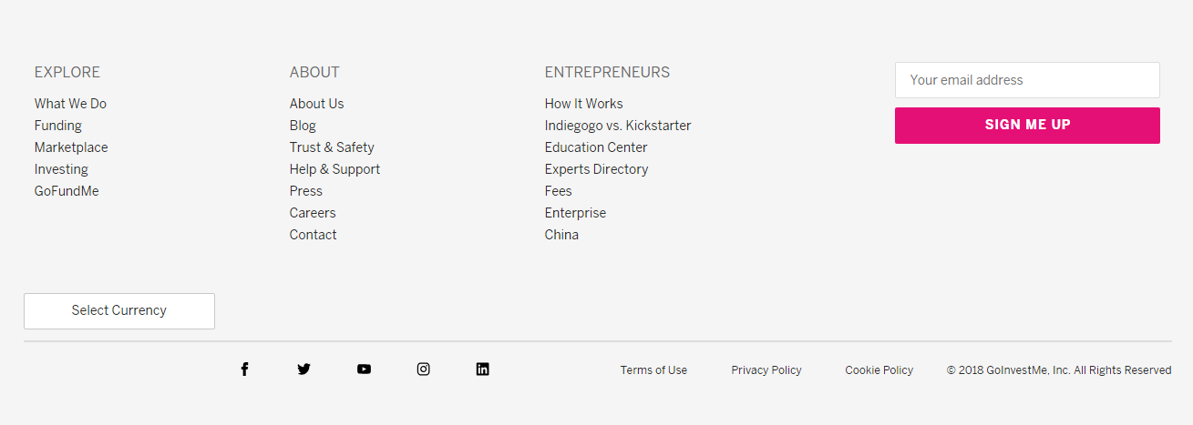

Figure 53: Footer

## Trending Projects

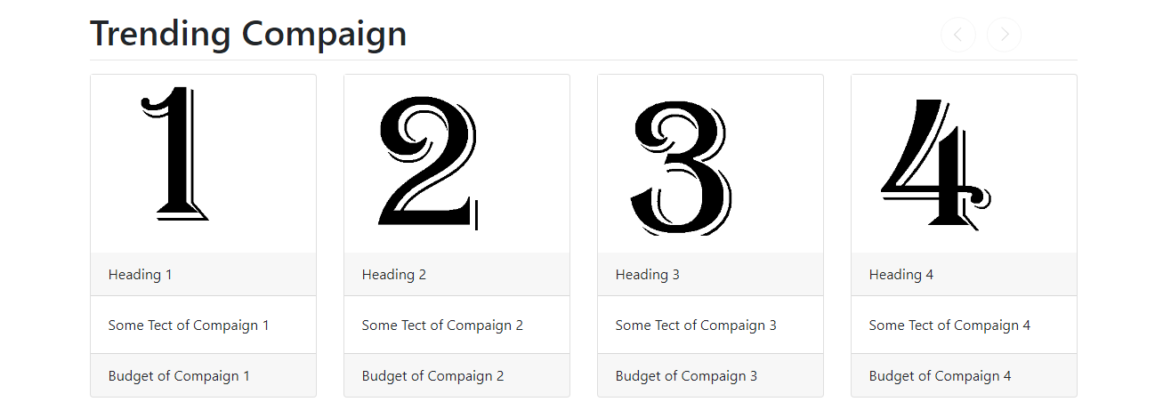

Figure 54: Trending Projects

## Search

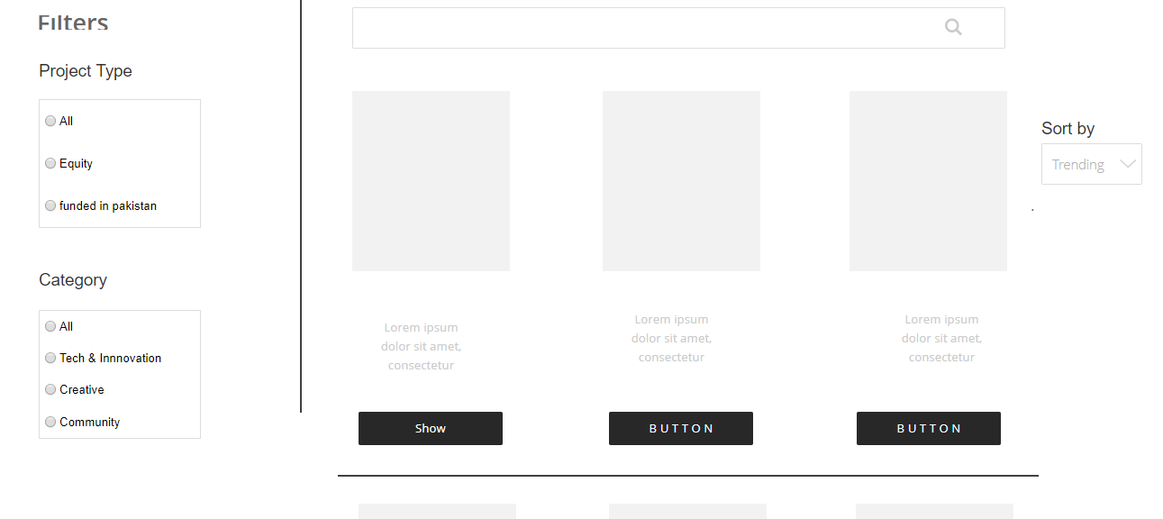

Figure 55: Search

## Show Campaign

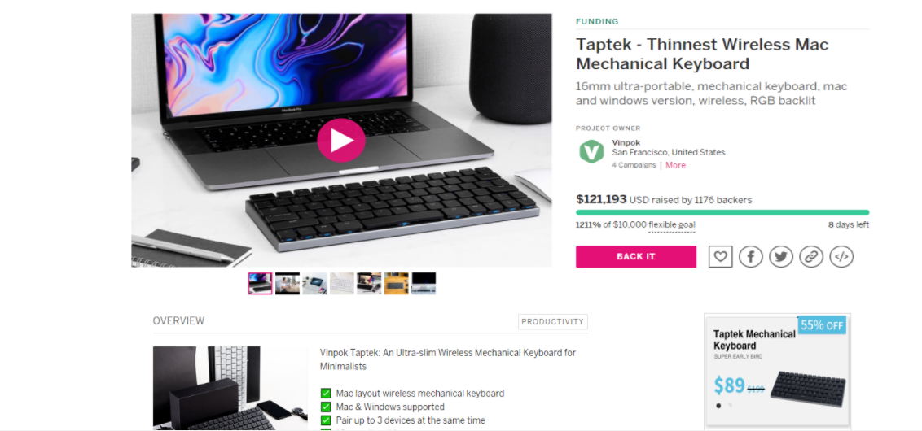

Figure 56: Show Campaign

## Sign Up

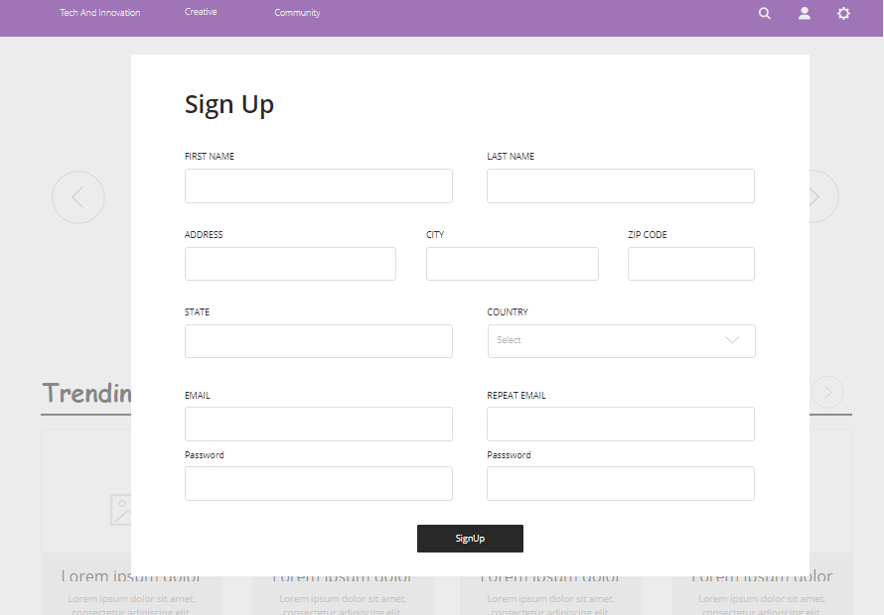

Figure 57: Sign Up

## Login

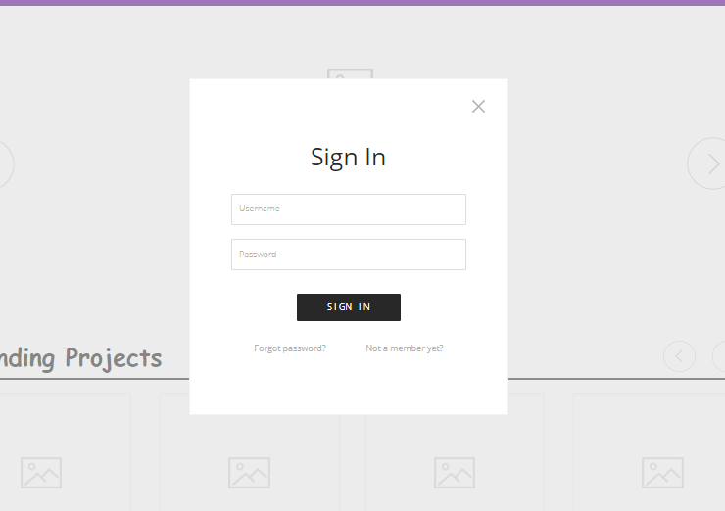

Figure 58: Login

## Detail for Investment

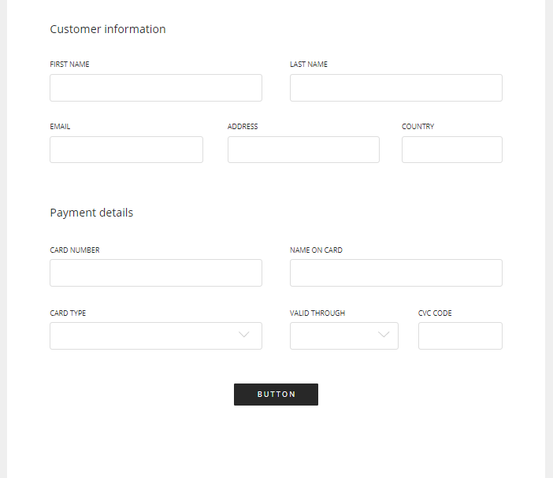

Figure 59: Detail for Investment

# Code

## _header.cshtml

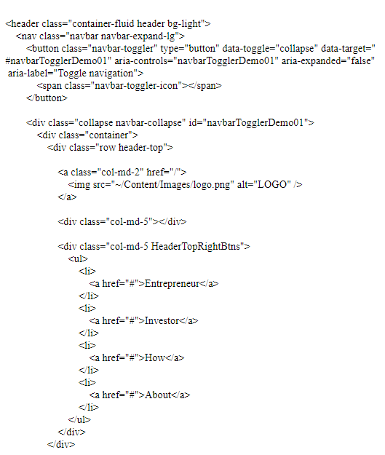

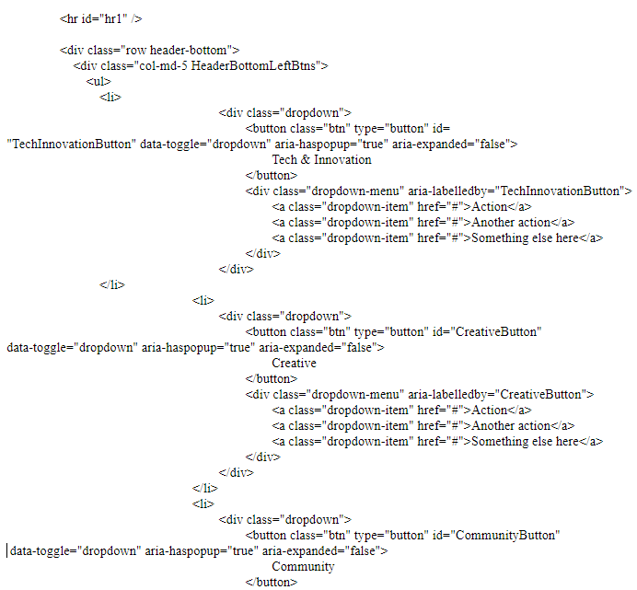

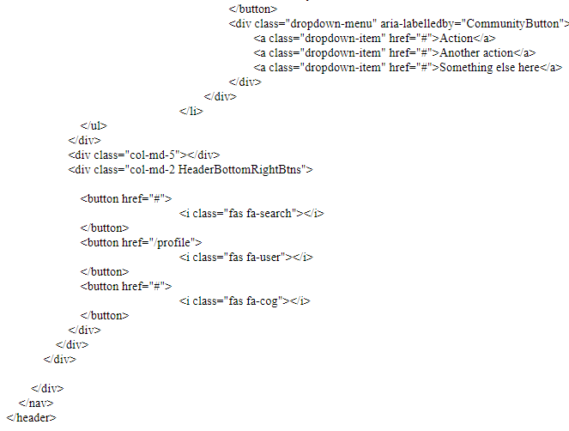

## _footer.cshtml

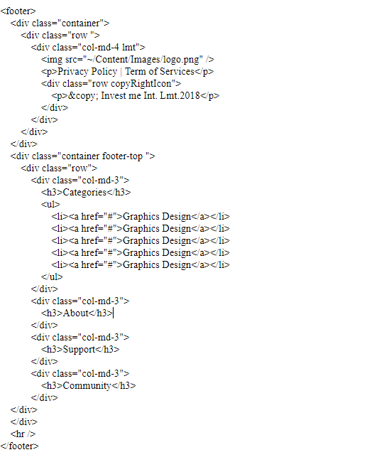

## _layout.cshtml

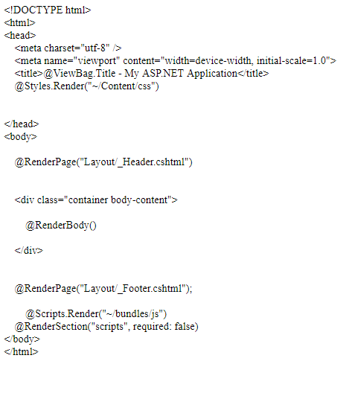

## Index

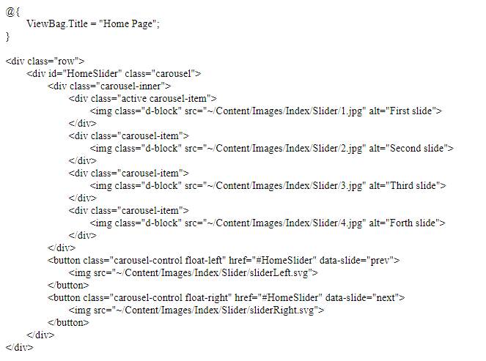

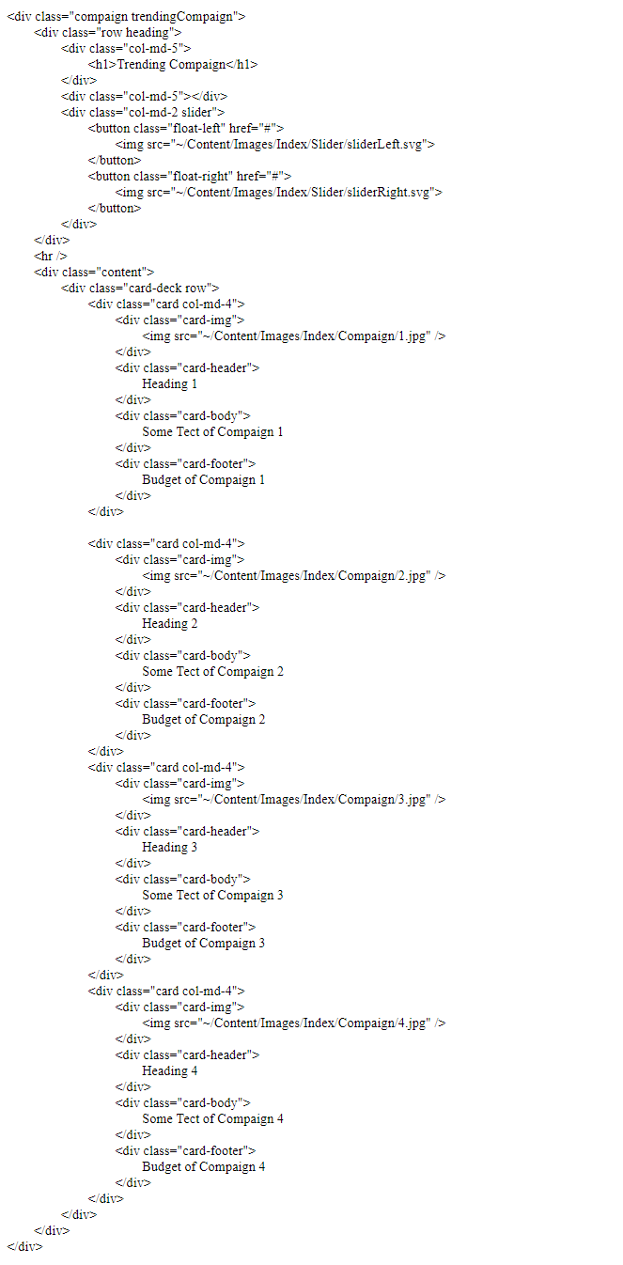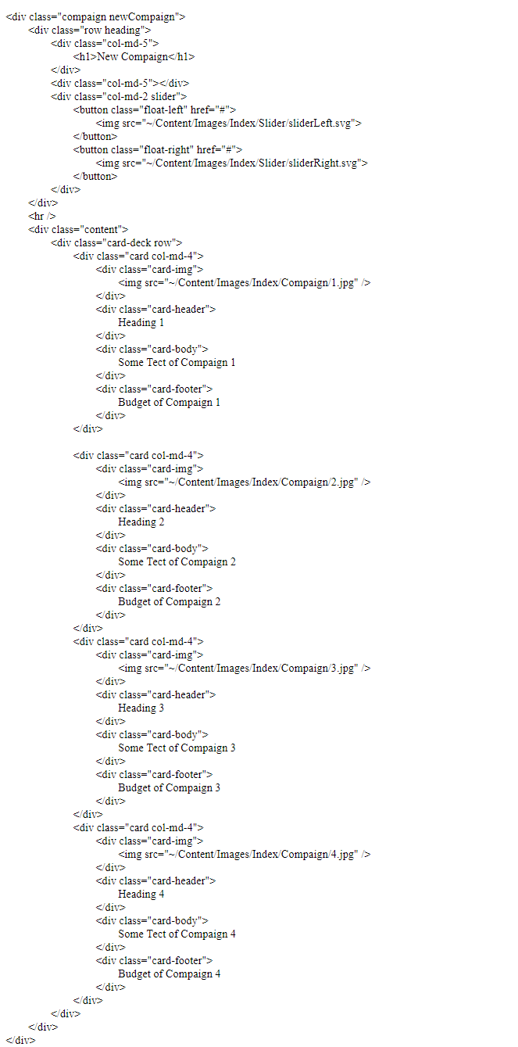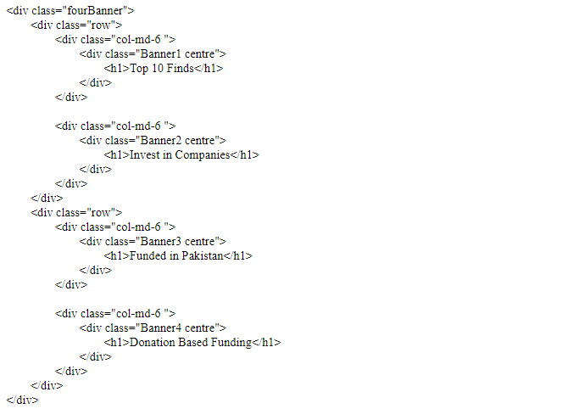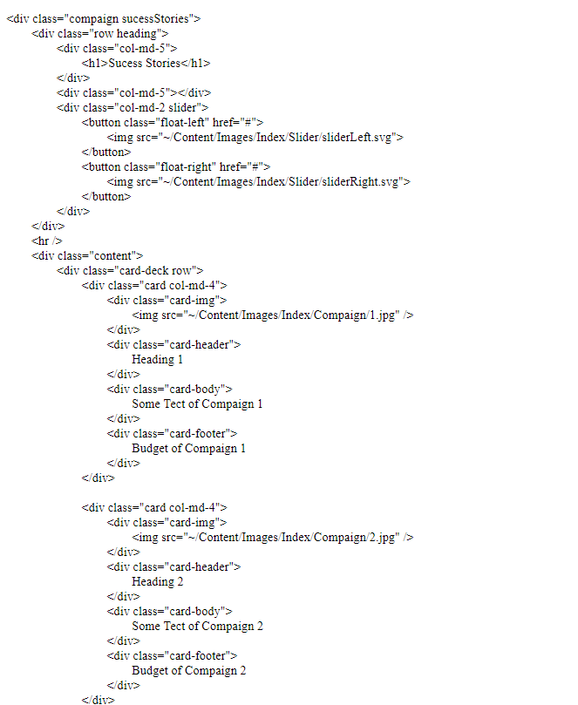

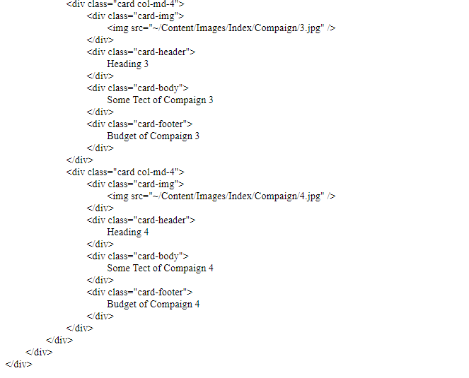

## Site.css

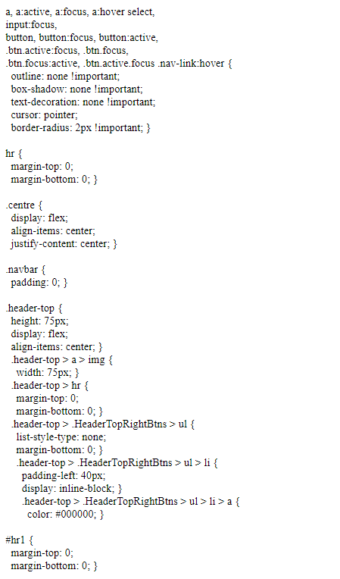

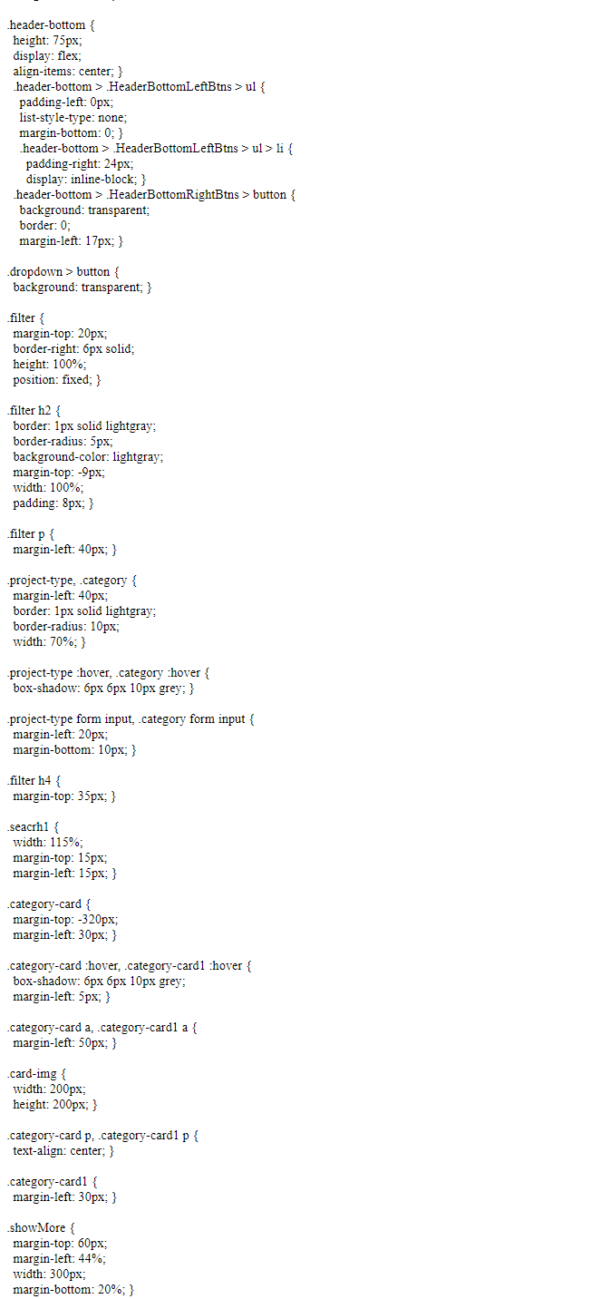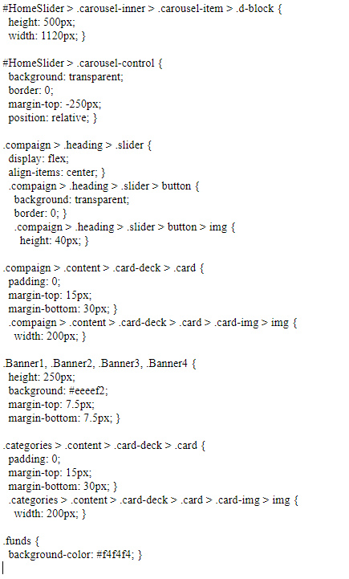

# Conclusion

To work in new domain cannot much straight forward, many problems faced while working on the project and leant lessons.

## **Problems**

* As this project was not of our domain, so we faced many problems while gathering data of this domain.
* Requirements were not precise and clear and were mostly changing with time.
* Scope changes due to requirement changing.
* We choose the frameworks that we did not study in our degree so we have to study it.
* Difficult to work with modern tools, as we have no experience before.
* This project was risk oriented because investment so was difficult to solve this.
* Main problem was to validate the account information from bank that was confidential for bank.

## **Lessons Learnt**

We learnt

* How to work professionally.
* How to tackle changing requirements
* How risks are countered.
* How to work with new technology.
* How to work for other domains
* Also, learn the modern tools and techniques how to use them.
* How to fulfil stakeholder needs.
* How to standardize methods, processes, tools and techniques?
* How to connect with other APIs.

## Project Summary

This Platform is designed for people who wants invest and get investment for their projects. It is place where entrepreneurs add their campaign and wait for investment. It is also give benefits to investor because they can increase their business scope. It saves a lot of time and effort of the people who to starts their own business but they have no investment they can get benefits from this platform. Data for the project collected by entrepreneur who fails in their ideas due to no more investment and by investors. Different website who are already working on some relative idea and we designed a project which compensated for the functionalities they all lacked while fulfilling all the other requirements of entrepreneur and investors. Moreover, give opportunity to companies invest money, add their campaign, and collect investment for their project. Keeping in view the advancement in web development, automation and upcoming web structure (WEB 3.0) all of the work is done by making and merging different ontologies with functionalities that will keep the user interacted with our project.

## Future Work

The future work that we plan to be done in this domain is as follow:

### Translation

We can translate our Platform into Multiple Language like Chinese, Korean, and Japanese because in some countries like China or Japan they prefer to use their Language instead of English. So our Platform is translated into their language they can also avail the services of our Platform in their Language.

Example, there are more than 250 Wikipedia Based on Language differences

### Artificial Intelligence

We can add Artificial Intelligence so that the Campaign is analyzed before any investment happen and the entrepreneur have idea how much investment he can receive.

### SSL Certification

We can get SSL Certificate for our platform, which inform our user that this platform is Safe to Use.

### Copyrights

We can get Copyrights by an accreditation body so that no one can copy our work without our Permission.

# References

|  |  |
| --- | --- |
| [1] | Brewer and Anthony, "Richard Cantillon: Pioneer of Economic Theory. Routledge," 1992. |
| [2] | W. S. Jevons, "Richard Cantillon and the Nationality of Political Economy," 1881. |
| [3] | R. Afschar, "Entry regulation and entrepreneurship: a natural experiment in German craftsmanship," 2013. |
| [4] | "Crowdfunding," 2018. [Online]. Available: https://www.investopedia.com/terms/c/crowdfunding.asp. |
| [5] | B. Feldman, "Why would a company choose to use an SQL server Over open-source databases," 27 October 2014. [Online]. |
| [6] | "Pledge Music Reviews - Legit or Scam?," 2017. [Online]. Available: https://www.reviewopedia.com/pledge-music-reviews. |
| [7] | "Indiegogo Review," 2018. [Online]. Available: https://www.merchantmaverick.com/reviews/indiegogo-review/. |
| [8] | "Kickstarter Review," 2018. [Online]. Available: https://www.merchantmaverick.com/reviews/kickstarter-review/. |
| [9] | "kickstarter Review," 2018. [Online]. Available: https://www.trustpilot.com/review/www.kickstarter.com. |
| [10] | Kalyan1052, "Advantages of asp.net over php," 22 June 2011. [Online]. |
| [12] | T. G. Flouris and D. Lock, in *Managing Aviation Projects from Concept to Completion. Ashgate Publishing Limited*, 2012. |
| [13] | "Uml Sequence," 2018. [Online]. Available: https://www.lucidchart.com/pages/uml-sequence-diagram. |
| [14] | R. Fulton and R. Vandermolen, "Chapter 4: Requirements - Writing Requirements," in *Airborne Electronic Hardware Design Assurance: A Practitioner's Guide to RTCA/DO-254.*, CRC Press, 2017, p. 89–93. |
| [15] | L. Chen, M. Ali Babar and B. Nuseibeh, "Characterizing Architecturally Significant Requirements," p. 38–45, 2013. |

